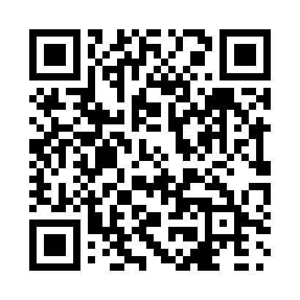
Prayer times for Trout Brook, New Brunswick, Canada
Mon 1 Apr 2024 - Tue 30 Apr 2024
High Latitude Method: Angle Based Rule
Prayer Calculation Method: Islamic Society of North America
Asar Calculation Method: Hanafi

Date | Day | Fajr | Sunrise | Dhuhr | Asr | Maghrib | Isha
1 | Mon | 5:34 | 7:01 | 1:27 | 5:56 | 7:53 | 9:21
2 | Tue | 5:32 | 6:59 | 1:27 | 5:57 | 7:55 | 9:22
3 | Wed | 5:30 | 6:57 | 1:26 | 5:58 | 7:56 | 9:24
4 | Thu | 5:27 | 6:55 | 1:26 | 5:59 | 7:58 | 9:26
5 | Fri | 5:25 | 6:53 | 1:26 | 6:00 | 7:59 | 9:27
6 | Sat | 5:23 | 6:51 | 1:25 | 6:01 | 8:00 | 9:29
7 | Sun | 5:21 | 6:49 | 1:25 | 6:02 | 8:02 | 9:31
8 | Mon | 5:18 | 6:47 | 1:25 | 6:03 | 8:03 | 9:32
9 | Tue | 5:16 | 6:46 | 1:25 | 6:04 | 8:04 | 9:34
10 | Wed | 5:14 | 6:44 | 1:24 | 6:04 | 8:06 | 9:36
11 | Thu | 5:12 | 6:42 | 1:24 | 6:05 | 8:07 | 9:38
12 | Fri | 5:09 | 6:40 | 1:24 | 6:06 | 8:09 | 9:39
13 | Sat | 5:07 | 6:38 | 1:24 | 6:07 | 8:10 | 9:41
14 | Sun | 5:05 | 6:36 | 1:23 | 6:08 | 8:11 | 9:43
15 | Mon | 5:02 | 6:34 | 1:23 | 6:09 | 8:13 | 9:45
16 | Tue | 5:00 | 6:32 | 1:23 | 6:10 | 8:14 | 9:47
17 | Wed | 4:58 | 6:30 | 1:23 | 6:11 | 8:16 | 9:48
18 | Thu | 4:56 | 6:29 | 1:22 | 6:12 | 8:17 | 9:50
19 | Fri | 4:53 | 6:27 | 1:22 | 6:13 | 8:18 | 9:52
20 | Sat | 4:51 | 6:25 | 1:22 | 6:14 | 8:20 | 9:54
21 | Sun | 4:49 | 6:23 | 1:22 | 6:14 | 8:21 | 9:56
22 | Mon | 4:46 | 6:21 | 1:22 | 6:15 | 8:22 | 9:58
23 | Tue | 4:44 | 6:20 | 1:21 | 6:16 | 8:24 | 10:00
24 | Wed | 4:42 | 6:18 | 1:21 | 6:17 | 8:25 | 10:02
25 | Thu | 4:40 | 6:16 | 1:21 | 6:18 | 8:27 | 10:04
26 | Fri | 4:37 | 6:15 | 1:21 | 6:19 | 8:28 | 10:06
27 | Sat | 4:35 | 6:13 | 1:21 | 6:20 | 8:29 | 10:07
28 | Sun | 4:33 | 6:11 | 1:21 | 6:20 | 8:31 | 10:09
29 | Mon | 4:31 | 6:10 | 1:20 | 6:21 | 8:32 | 10:11
30 | Tue | 4:28 | 6:08 | 1:20 | 6:22 | 8:33 | 10:13
Prayer times provided by https://www.salahtimes.com

