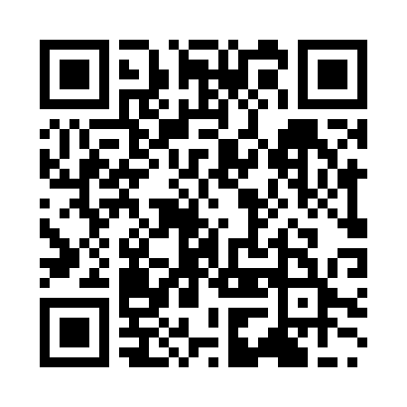
Prayer times for Nakatsu, Japan
Mon 1 Apr 2024 - Tue 30 Apr 2024
High Latitude Method: None
Prayer Calculation Method: Muslim World League
Asar Calculation Method: Shafi

Date | Day | Fajr | Sunrise | Dhuhr | Asr | Maghrib | Isha
1 | Mon | 4:38 | 6:03 | 12:19 | 3:52 | 6:36 | 7:55
2 | Tue | 4:37 | 6:02 | 12:19 | 3:52 | 6:37 | 7:56
3 | Wed | 4:35 | 6:00 | 12:19 | 3:53 | 6:37 | 7:57
4 | Thu | 4:34 | 5:59 | 12:18 | 3:53 | 6:38 | 7:58
5 | Fri | 4:32 | 5:58 | 12:18 | 3:53 | 6:39 | 7:59
6 | Sat | 4:31 | 5:56 | 12:18 | 3:53 | 6:40 | 8:00
7 | Sun | 4:29 | 5:55 | 12:17 | 3:53 | 6:40 | 8:01
8 | Mon | 4:28 | 5:54 | 12:17 | 3:53 | 6:41 | 8:02
9 | Tue | 4:27 | 5:52 | 12:17 | 3:53 | 6:42 | 8:03
10 | Wed | 4:25 | 5:51 | 12:17 | 3:53 | 6:43 | 8:04
11 | Thu | 4:24 | 5:50 | 12:16 | 3:53 | 6:43 | 8:04
12 | Fri | 4:22 | 5:49 | 12:16 | 3:53 | 6:44 | 8:05
13 | Sat | 4:21 | 5:47 | 12:16 | 3:53 | 6:45 | 8:06
14 | Sun | 4:19 | 5:46 | 12:16 | 3:54 | 6:45 | 8:07
15 | Mon | 4:18 | 5:45 | 12:15 | 3:54 | 6:46 | 8:08
16 | Tue | 4:16 | 5:44 | 12:15 | 3:54 | 6:47 | 8:09
17 | Wed | 4:15 | 5:42 | 12:15 | 3:54 | 6:48 | 8:10
18 | Thu | 4:13 | 5:41 | 12:15 | 3:54 | 6:48 | 8:11
19 | Fri | 4:12 | 5:40 | 12:14 | 3:54 | 6:49 | 8:12
20 | Sat | 4:10 | 5:39 | 12:14 | 3:54 | 6:50 | 8:13
21 | Sun | 4:09 | 5:38 | 12:14 | 3:54 | 6:51 | 8:14
22 | Mon | 4:07 | 5:36 | 12:14 | 3:54 | 6:52 | 8:15
23 | Tue | 4:06 | 5:35 | 12:14 | 3:54 | 6:52 | 8:16
24 | Wed | 4:05 | 5:34 | 12:13 | 3:54 | 6:53 | 8:17
25 | Thu | 4:03 | 5:33 | 12:13 | 3:54 | 6:54 | 8:18
26 | Fri | 4:02 | 5:32 | 12:13 | 3:54 | 6:55 | 8:19
27 | Sat | 4:01 | 5:31 | 12:13 | 3:54 | 6:55 | 8:20
28 | Sun | 3:59 | 5:30 | 12:13 | 3:54 | 6:56 | 8:21
29 | Mon | 3:58 | 5:29 | 12:13 | 3:54 | 6:57 | 8:22
30 | Tue | 3:56 | 5:28 | 12:12 | 3:54 | 6:58 | 8:23
Prayer times provided by https://www.salahtimes.com

