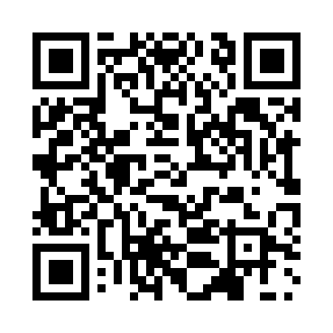
Prayer times for Iveldingen, Belgium
Wed 1 May 2024 - Fri 31 May 2024
High Latitude Method: Angle Based Rule
Prayer Calculation Method: Muslim World League
Asar Calculation Method: Shafi

Date | Day | Fajr | Sunrise | Dhuhr | Asr | Maghrib | Isha
1 | Wed | 3:48 | 6:10 | 1:33 | 5:34 | 8:56 | 11:08
2 | Thu | 3:45 | 6:08 | 1:32 | 5:35 | 8:57 | 11:11
3 | Fri | 3:42 | 6:07 | 1:32 | 5:36 | 8:59 | 11:14
4 | Sat | 3:38 | 6:05 | 1:32 | 5:36 | 9:01 | 11:16
5 | Sun | 3:35 | 6:03 | 1:32 | 5:37 | 9:02 | 11:19
6 | Mon | 3:32 | 6:01 | 1:32 | 5:38 | 9:04 | 11:22
7 | Tue | 3:28 | 6:00 | 1:32 | 5:38 | 9:05 | 11:25
8 | Wed | 3:25 | 5:58 | 1:32 | 5:39 | 9:07 | 11:28
9 | Thu | 3:21 | 5:57 | 1:32 | 5:39 | 9:08 | 11:31
10 | Fri | 3:18 | 5:55 | 1:32 | 5:40 | 9:10 | 11:34
11 | Sat | 3:17 | 5:53 | 1:32 | 5:40 | 9:11 | 11:37
12 | Sun | 3:16 | 5:52 | 1:32 | 5:41 | 9:13 | 11:40
13 | Mon | 3:16 | 5:50 | 1:32 | 5:42 | 9:14 | 11:40
14 | Tue | 3:15 | 5:49 | 1:32 | 5:42 | 9:15 | 11:41
15 | Wed | 3:14 | 5:48 | 1:32 | 5:43 | 9:17 | 11:42
16 | Thu | 3:14 | 5:46 | 1:32 | 5:43 | 9:18 | 11:42
17 | Fri | 3:13 | 5:45 | 1:32 | 5:44 | 9:20 | 11:43
18 | Sat | 3:13 | 5:44 | 1:32 | 5:44 | 9:21 | 11:43
19 | Sun | 3:12 | 5:42 | 1:32 | 5:45 | 9:22 | 11:44
20 | Mon | 3:12 | 5:41 | 1:32 | 5:45 | 9:24 | 11:45
21 | Tue | 3:11 | 5:40 | 1:32 | 5:46 | 9:25 | 11:45
22 | Wed | 3:11 | 5:39 | 1:32 | 5:46 | 9:26 | 11:46
23 | Thu | 3:11 | 5:38 | 1:32 | 5:47 | 9:28 | 11:46
24 | Fri | 3:10 | 5:36 | 1:32 | 5:47 | 9:29 | 11:47
25 | Sat | 3:10 | 5:35 | 1:33 | 5:48 | 9:30 | 11:48
26 | Sun | 3:10 | 5:34 | 1:33 | 5:48 | 9:31 | 11:48
27 | Mon | 3:09 | 5:33 | 1:33 | 5:49 | 9:33 | 11:49
28 | Tue | 3:09 | 5:33 | 1:33 | 5:49 | 9:34 | 11:49
29 | Wed | 3:09 | 5:32 | 1:33 | 5:50 | 9:35 | 11:50
30 | Thu | 3:08 | 5:31 | 1:33 | 5:50 | 9:36 | 11:51
31 | Fri | 3:08 | 5:30 | 1:33 | 5:51 | 9:37 | 11:51
Prayer times provided by https://www.salahtimes.com

