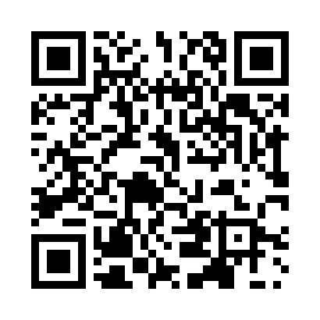
Prayer times for Atembeek, Belgium
Mon 1 Apr 2024 - Tue 30 Apr 2024
High Latitude Method: Angle Based Rule
Prayer Calculation Method: Muslim World League
Asar Calculation Method: Shafi

Date | Day | Fajr | Sunrise | Dhuhr | Asr | Maghrib | Isha
1 | Mon | 5:23 | 7:19 | 1:48 | 5:22 | 8:18 | 10:07
2 | Tue | 5:20 | 7:17 | 1:48 | 5:22 | 8:19 | 10:09
3 | Wed | 5:18 | 7:15 | 1:47 | 5:23 | 8:21 | 10:11
4 | Thu | 5:15 | 7:13 | 1:47 | 5:24 | 8:22 | 10:13
5 | Fri | 5:12 | 7:11 | 1:47 | 5:25 | 8:24 | 10:15
6 | Sat | 5:09 | 7:08 | 1:47 | 5:26 | 8:26 | 10:18
7 | Sun | 5:06 | 7:06 | 1:46 | 5:27 | 8:27 | 10:20
8 | Mon | 5:04 | 7:04 | 1:46 | 5:27 | 8:29 | 10:22
9 | Tue | 5:01 | 7:02 | 1:46 | 5:28 | 8:31 | 10:24
10 | Wed | 4:58 | 7:00 | 1:46 | 5:29 | 8:32 | 10:27
11 | Thu | 4:55 | 6:58 | 1:45 | 5:30 | 8:34 | 10:29
12 | Fri | 4:52 | 6:56 | 1:45 | 5:30 | 8:35 | 10:31
13 | Sat | 4:49 | 6:53 | 1:45 | 5:31 | 8:37 | 10:33
14 | Sun | 4:46 | 6:51 | 1:44 | 5:32 | 8:39 | 10:36
15 | Mon | 4:43 | 6:49 | 1:44 | 5:33 | 8:40 | 10:38
16 | Tue | 4:40 | 6:47 | 1:44 | 5:33 | 8:42 | 10:41
17 | Wed | 4:37 | 6:45 | 1:44 | 5:34 | 8:43 | 10:43
18 | Thu | 4:34 | 6:43 | 1:44 | 5:35 | 8:45 | 10:46
19 | Fri | 4:31 | 6:41 | 1:43 | 5:36 | 8:47 | 10:48
20 | Sat | 4:28 | 6:39 | 1:43 | 5:36 | 8:48 | 10:51
21 | Sun | 4:25 | 6:37 | 1:43 | 5:37 | 8:50 | 10:53
22 | Mon | 4:22 | 6:35 | 1:43 | 5:38 | 8:52 | 10:56
23 | Tue | 4:19 | 6:33 | 1:43 | 5:38 | 8:53 | 10:58
24 | Wed | 4:16 | 6:31 | 1:42 | 5:39 | 8:55 | 11:01
25 | Thu | 4:13 | 6:29 | 1:42 | 5:40 | 8:56 | 11:04
26 | Fri | 4:09 | 6:27 | 1:42 | 5:40 | 8:58 | 11:06
27 | Sat | 4:06 | 6:25 | 1:42 | 5:41 | 9:00 | 11:09
28 | Sun | 4:03 | 6:23 | 1:42 | 5:42 | 9:01 | 11:12
29 | Mon | 4:00 | 6:21 | 1:42 | 5:42 | 9:03 | 11:15
30 | Tue | 3:56 | 6:19 | 1:42 | 5:43 | 9:04 | 11:17
Prayer times provided by https://www.salahtimes.com

