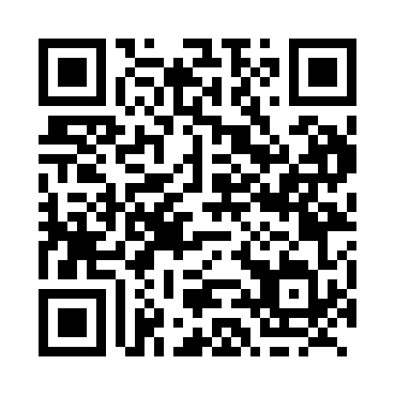
Prayer times for Ombabika, Ontario, Canada
Mon 1 Jul 2024 - Wed 31 Jul 2024
High Latitude Method: Angle Based Rule
Prayer Calculation Method: Islamic Society of North America
Asar Calculation Method: Hanafi

Date | Day | Fajr | Sunrise | Dhuhr | Asr | Maghrib | Isha
1 | Mon | 3:51 | 5:46 | 1:56 | 7:29 | 10:05 | 12:00
2 | Tue | 3:51 | 5:47 | 1:56 | 7:29 | 10:05 | 12:00
3 | Wed | 3:52 | 5:47 | 1:56 | 7:29 | 10:04 | 12:00
4 | Thu | 3:52 | 5:48 | 1:56 | 7:28 | 10:04 | 12:00
5 | Fri | 3:53 | 5:49 | 1:56 | 7:28 | 10:03 | 12:00
6 | Sat | 3:53 | 5:50 | 1:57 | 7:28 | 10:03 | 12:00
7 | Sun | 3:54 | 5:51 | 1:57 | 7:28 | 10:02 | 11:59
8 | Mon | 3:54 | 5:52 | 1:57 | 7:28 | 10:02 | 11:59
9 | Tue | 3:55 | 5:53 | 1:57 | 7:27 | 10:01 | 11:59
10 | Wed | 3:55 | 5:54 | 1:57 | 7:27 | 10:00 | 11:59
11 | Thu | 3:56 | 5:55 | 1:57 | 7:27 | 9:59 | 11:58
12 | Fri | 3:56 | 5:56 | 1:57 | 7:26 | 9:59 | 11:58
13 | Sat | 3:57 | 5:57 | 1:58 | 7:26 | 9:58 | 11:58
14 | Sun | 3:58 | 5:58 | 1:58 | 7:25 | 9:57 | 11:57
15 | Mon | 3:58 | 5:59 | 1:58 | 7:25 | 9:56 | 11:57
16 | Tue | 3:59 | 6:00 | 1:58 | 7:24 | 9:55 | 11:56
17 | Wed | 3:59 | 6:01 | 1:58 | 7:24 | 9:54 | 11:56
18 | Thu | 4:00 | 6:03 | 1:58 | 7:23 | 9:53 | 11:55
19 | Fri | 4:01 | 6:04 | 1:58 | 7:23 | 9:52 | 11:55
20 | Sat | 4:01 | 6:05 | 1:58 | 7:22 | 9:51 | 11:54
21 | Sun | 4:02 | 6:06 | 1:58 | 7:21 | 9:49 | 11:54
22 | Mon | 4:03 | 6:08 | 1:58 | 7:21 | 9:48 | 11:53
23 | Tue | 4:03 | 6:09 | 1:58 | 7:20 | 9:47 | 11:52
24 | Wed | 4:04 | 6:10 | 1:58 | 7:19 | 9:46 | 11:52
25 | Thu | 4:05 | 6:11 | 1:58 | 7:19 | 9:44 | 11:51
26 | Fri | 4:06 | 6:13 | 1:58 | 7:18 | 9:43 | 11:49
27 | Sat | 4:09 | 6:14 | 1:58 | 7:17 | 9:41 | 11:46
28 | Sun | 4:11 | 6:16 | 1:58 | 7:16 | 9:40 | 11:44
29 | Mon | 4:14 | 6:17 | 1:58 | 7:15 | 9:39 | 11:41
30 | Tue | 4:16 | 6:18 | 1:58 | 7:14 | 9:37 | 11:39
31 | Wed | 4:19 | 6:20 | 1:58 | 7:13 | 9:36 | 11:36
Prayer times provided by https://www.salahtimes.com

