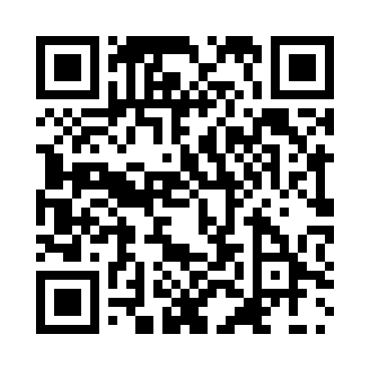
Prayer times for Chargram, Bangladesh
Wed 1 May 2024 - Fri 31 May 2024
High Latitude Method: None
Prayer Calculation Method: University of Islamic Sciences
Asar Calculation Method: Shafi

Date | Day | Fajr | Sunrise | Dhuhr | Asr | Maghrib | Isha
1 | Wed | 3:53 | 5:15 | 11:47 | 3:16 | 6:21 | 7:42
2 | Thu | 3:52 | 5:14 | 11:47 | 3:15 | 6:21 | 7:43
3 | Fri | 3:51 | 5:13 | 11:47 | 3:15 | 6:22 | 7:44
4 | Sat | 3:50 | 5:13 | 11:47 | 3:15 | 6:22 | 7:45
5 | Sun | 3:49 | 5:12 | 11:47 | 3:15 | 6:23 | 7:45
6 | Mon | 3:48 | 5:11 | 11:47 | 3:14 | 6:23 | 7:46
7 | Tue | 3:48 | 5:11 | 11:47 | 3:14 | 6:24 | 7:47
8 | Wed | 3:47 | 5:10 | 11:47 | 3:14 | 6:24 | 7:47
9 | Thu | 3:46 | 5:09 | 11:47 | 3:14 | 6:25 | 7:48
10 | Fri | 3:45 | 5:09 | 11:47 | 3:14 | 6:25 | 7:49
11 | Sat | 3:44 | 5:08 | 11:47 | 3:13 | 6:26 | 7:50
12 | Sun | 3:44 | 5:08 | 11:47 | 3:13 | 6:26 | 7:50
13 | Mon | 3:43 | 5:07 | 11:47 | 3:13 | 6:27 | 7:51
14 | Tue | 3:42 | 5:07 | 11:47 | 3:13 | 6:27 | 7:52
15 | Wed | 3:41 | 5:06 | 11:47 | 3:13 | 6:28 | 7:53
16 | Thu | 3:41 | 5:06 | 11:47 | 3:13 | 6:28 | 7:53
17 | Fri | 3:40 | 5:05 | 11:47 | 3:12 | 6:29 | 7:54
18 | Sat | 3:39 | 5:05 | 11:47 | 3:12 | 6:29 | 7:55
19 | Sun | 3:39 | 5:04 | 11:47 | 3:12 | 6:30 | 7:55
20 | Mon | 3:38 | 5:04 | 11:47 | 3:12 | 6:30 | 7:56
21 | Tue | 3:38 | 5:03 | 11:47 | 3:12 | 6:31 | 7:57
22 | Wed | 3:37 | 5:03 | 11:47 | 3:12 | 6:31 | 7:57
23 | Thu | 3:37 | 5:03 | 11:47 | 3:12 | 6:32 | 7:58
24 | Fri | 3:36 | 5:02 | 11:47 | 3:12 | 6:32 | 7:59
25 | Sat | 3:36 | 5:02 | 11:47 | 3:12 | 6:33 | 8:00
26 | Sun | 3:35 | 5:02 | 11:48 | 3:12 | 6:33 | 8:00
27 | Mon | 3:35 | 5:02 | 11:48 | 3:12 | 6:34 | 8:01
28 | Tue | 3:34 | 5:01 | 11:48 | 3:12 | 6:34 | 8:01
29 | Wed | 3:34 | 5:01 | 11:48 | 3:12 | 6:35 | 8:02
30 | Thu | 3:34 | 5:01 | 11:48 | 3:12 | 6:35 | 8:03
31 | Fri | 3:33 | 5:01 | 11:48 | 3:12 | 6:36 | 8:03
Prayer times provided by https://www.salahtimes.com

