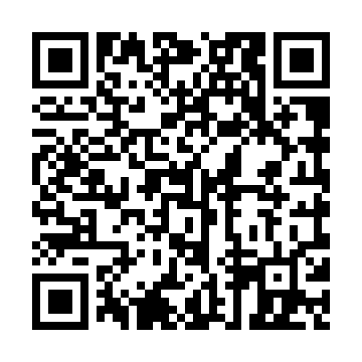
Prayer times for Schefferville, Quebec, Canada
Mon 1 Jul 2024 - Wed 31 Jul 2024
High Latitude Method: Angle Based Rule
Prayer Calculation Method: Islamic Society of North America
Asar Calculation Method: Hanafi

Date | Day | Fajr | Sunrise | Dhuhr | Asr | Maghrib | Isha
1 | Mon | 2:13 | 3:55 | 12:31 | 6:15 | 9:07 | 10:49
2 | Tue | 2:14 | 3:56 | 12:32 | 6:15 | 9:07 | 10:49
3 | Wed | 2:14 | 3:57 | 12:32 | 6:15 | 9:06 | 10:49
4 | Thu | 2:15 | 3:58 | 12:32 | 6:15 | 9:06 | 10:49
5 | Fri | 2:15 | 3:59 | 12:32 | 6:15 | 9:05 | 10:49
6 | Sat | 2:16 | 4:00 | 12:32 | 6:14 | 9:04 | 10:48
7 | Sun | 2:16 | 4:01 | 12:32 | 6:14 | 9:04 | 10:48
8 | Mon | 2:17 | 4:02 | 12:33 | 6:14 | 9:03 | 10:48
9 | Tue | 2:18 | 4:03 | 12:33 | 6:13 | 9:02 | 10:47
10 | Wed | 2:18 | 4:04 | 12:33 | 6:13 | 9:01 | 10:47
11 | Thu | 2:19 | 4:05 | 12:33 | 6:12 | 9:00 | 10:46
12 | Fri | 2:20 | 4:07 | 12:33 | 6:12 | 8:59 | 10:46
13 | Sat | 2:20 | 4:08 | 12:33 | 6:11 | 8:58 | 10:45
14 | Sun | 2:21 | 4:09 | 12:33 | 6:11 | 8:57 | 10:45
15 | Mon | 2:22 | 4:11 | 12:33 | 6:10 | 8:55 | 10:44
16 | Tue | 2:23 | 4:12 | 12:33 | 6:10 | 8:54 | 10:44
17 | Wed | 2:23 | 4:14 | 12:34 | 6:09 | 8:53 | 10:43
18 | Thu | 2:24 | 4:15 | 12:34 | 6:08 | 8:51 | 10:42
19 | Fri | 2:25 | 4:17 | 12:34 | 6:07 | 8:50 | 10:42
20 | Sat | 2:26 | 4:18 | 12:34 | 6:07 | 8:49 | 10:41
21 | Sun | 2:27 | 4:20 | 12:34 | 6:06 | 8:47 | 10:40
22 | Mon | 2:27 | 4:21 | 12:34 | 6:05 | 8:46 | 10:39
23 | Tue | 2:28 | 4:23 | 12:34 | 6:04 | 8:44 | 10:39
24 | Wed | 2:29 | 4:25 | 12:34 | 6:03 | 8:42 | 10:38
25 | Thu | 2:30 | 4:26 | 12:34 | 6:02 | 8:41 | 10:37
26 | Fri | 2:31 | 4:28 | 12:34 | 6:01 | 8:39 | 10:36
27 | Sat | 2:32 | 4:30 | 12:34 | 6:00 | 8:37 | 10:35
28 | Sun | 2:32 | 4:31 | 12:34 | 5:59 | 8:35 | 10:34
29 | Mon | 2:33 | 4:33 | 12:34 | 5:58 | 8:34 | 10:34
30 | Tue | 2:34 | 4:35 | 12:34 | 5:57 | 8:32 | 10:33
31 | Wed | 2:35 | 4:37 | 12:34 | 5:56 | 8:30 | 10:32
Prayer times provided by https://www.salahtimes.com

