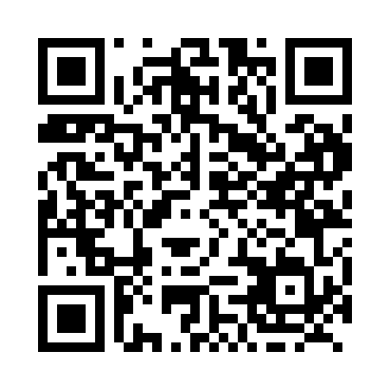
Prayer times for Chambord, Quebec, Canada
Wed 1 May 2024 - Fri 31 May 2024
High Latitude Method: Angle Based Rule
Prayer Calculation Method: Islamic Society of North America
Asar Calculation Method: Hanafi

Date | Day | Fajr | Sunrise | Dhuhr | Asr | Maghrib | Isha
1 | Wed | 3:44 | 5:28 | 12:45 | 5:49 | 8:03 | 9:48
2 | Thu | 3:41 | 5:26 | 12:45 | 5:50 | 8:05 | 9:50
3 | Fri | 3:39 | 5:25 | 12:45 | 5:51 | 8:06 | 9:53
4 | Sat | 3:36 | 5:23 | 12:45 | 5:52 | 8:08 | 9:55
5 | Sun | 3:34 | 5:22 | 12:45 | 5:53 | 8:09 | 9:57
6 | Mon | 3:32 | 5:20 | 12:45 | 5:54 | 8:10 | 9:59
7 | Tue | 3:29 | 5:18 | 12:45 | 5:55 | 8:12 | 10:01
8 | Wed | 3:27 | 5:17 | 12:45 | 5:55 | 8:13 | 10:04
9 | Thu | 3:25 | 5:15 | 12:45 | 5:56 | 8:15 | 10:06
10 | Fri | 3:23 | 5:14 | 12:45 | 5:57 | 8:16 | 10:08
11 | Sat | 3:20 | 5:13 | 12:45 | 5:58 | 8:17 | 10:10
12 | Sun | 3:18 | 5:11 | 12:45 | 5:59 | 8:19 | 10:12
13 | Mon | 3:16 | 5:10 | 12:45 | 5:59 | 8:20 | 10:15
14 | Tue | 3:14 | 5:09 | 12:45 | 6:00 | 8:21 | 10:17
15 | Wed | 3:12 | 5:07 | 12:45 | 6:01 | 8:23 | 10:19
16 | Thu | 3:09 | 5:06 | 12:45 | 6:02 | 8:24 | 10:21
17 | Fri | 3:07 | 5:05 | 12:45 | 6:03 | 8:25 | 10:23
18 | Sat | 3:05 | 5:04 | 12:45 | 6:03 | 8:27 | 10:25
19 | Sun | 3:03 | 5:02 | 12:45 | 6:04 | 8:28 | 10:28
20 | Mon | 3:01 | 5:01 | 12:45 | 6:05 | 8:29 | 10:30
21 | Tue | 2:59 | 5:00 | 12:45 | 6:05 | 8:30 | 10:32
22 | Wed | 2:57 | 4:59 | 12:45 | 6:06 | 8:31 | 10:34
23 | Thu | 2:55 | 4:58 | 12:45 | 6:07 | 8:33 | 10:36
24 | Fri | 2:53 | 4:57 | 12:45 | 6:08 | 8:34 | 10:38
25 | Sat | 2:51 | 4:56 | 12:45 | 6:08 | 8:35 | 10:40
26 | Sun | 2:50 | 4:55 | 12:45 | 6:09 | 8:36 | 10:41
27 | Mon | 2:50 | 4:54 | 12:46 | 6:10 | 8:37 | 10:41
28 | Tue | 2:50 | 4:54 | 12:46 | 6:10 | 8:38 | 10:42
29 | Wed | 2:49 | 4:53 | 12:46 | 6:11 | 8:39 | 10:43
30 | Thu | 2:49 | 4:52 | 12:46 | 6:11 | 8:40 | 10:43
31 | Fri | 2:49 | 4:51 | 12:46 | 6:12 | 8:41 | 10:44
Prayer times provided by https://www.salahtimes.com

