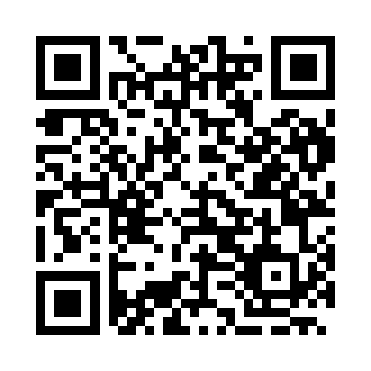
Prayer times for Kriva Bara, Bulgaria
Wed 1 May 2024 - Fri 31 May 2024
High Latitude Method: Angle Based Rule
Prayer Calculation Method: Muslim World League
Asar Calculation Method: Hanafi

Date | Day | Fajr | Sunrise | Dhuhr | Asr | Maghrib | Isha
1 | Wed | 4:26 | 6:20 | 1:25 | 6:24 | 8:31 | 10:17
2 | Thu | 4:24 | 6:18 | 1:25 | 6:24 | 8:32 | 10:18
3 | Fri | 4:22 | 6:17 | 1:25 | 6:25 | 8:33 | 10:20
4 | Sat | 4:20 | 6:15 | 1:24 | 6:26 | 8:34 | 10:22
5 | Sun | 4:18 | 6:14 | 1:24 | 6:26 | 8:35 | 10:24
6 | Mon | 4:16 | 6:13 | 1:24 | 6:27 | 8:36 | 10:25
7 | Tue | 4:14 | 6:12 | 1:24 | 6:28 | 8:38 | 10:27
8 | Wed | 4:12 | 6:10 | 1:24 | 6:28 | 8:39 | 10:29
9 | Thu | 4:10 | 6:09 | 1:24 | 6:29 | 8:40 | 10:31
10 | Fri | 4:08 | 6:08 | 1:24 | 6:30 | 8:41 | 10:33
11 | Sat | 4:06 | 6:07 | 1:24 | 6:30 | 8:42 | 10:34
12 | Sun | 4:05 | 6:05 | 1:24 | 6:31 | 8:43 | 10:36
13 | Mon | 4:03 | 6:04 | 1:24 | 6:32 | 8:44 | 10:38
14 | Tue | 4:01 | 6:03 | 1:24 | 6:32 | 8:45 | 10:40
15 | Wed | 3:59 | 6:02 | 1:24 | 6:33 | 8:46 | 10:41
16 | Thu | 3:57 | 6:01 | 1:24 | 6:33 | 8:48 | 10:43
17 | Fri | 3:55 | 6:00 | 1:24 | 6:34 | 8:49 | 10:45
18 | Sat | 3:54 | 5:59 | 1:24 | 6:35 | 8:50 | 10:47
19 | Sun | 3:52 | 5:58 | 1:24 | 6:35 | 8:51 | 10:48
20 | Mon | 3:50 | 5:57 | 1:24 | 6:36 | 8:52 | 10:50
21 | Tue | 3:49 | 5:56 | 1:24 | 6:37 | 8:53 | 10:52
22 | Wed | 3:47 | 5:56 | 1:24 | 6:37 | 8:54 | 10:53
23 | Thu | 3:45 | 5:55 | 1:24 | 6:38 | 8:55 | 10:55
24 | Fri | 3:44 | 5:54 | 1:25 | 6:38 | 8:56 | 10:57
25 | Sat | 3:42 | 5:53 | 1:25 | 6:39 | 8:57 | 10:58
26 | Sun | 3:41 | 5:52 | 1:25 | 6:39 | 8:58 | 11:00
27 | Mon | 3:39 | 5:52 | 1:25 | 6:40 | 8:58 | 11:01
28 | Tue | 3:38 | 5:51 | 1:25 | 6:41 | 8:59 | 11:03
29 | Wed | 3:37 | 5:50 | 1:25 | 6:41 | 9:00 | 11:04
30 | Thu | 3:35 | 5:50 | 1:25 | 6:42 | 9:01 | 11:06
31 | Fri | 3:34 | 5:49 | 1:25 | 6:42 | 9:02 | 11:07
Prayer times provided by https://www.salahtimes.com

