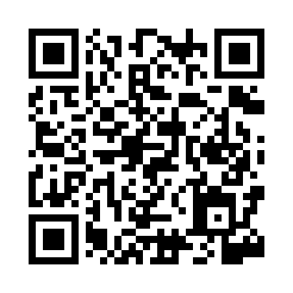
Prayer times for El Borma, Tunisia
Wed 1 May 2024 - Fri 31 May 2024
High Latitude Method: Angle Based Rule
Prayer Calculation Method: Tunisian Ministry of Religious Affairs
Asar Calculation Method: Shafi

Date | Day | Fajr | Sunrise | Dhuhr | Asr | Maghrib | Isha
1 | Wed | 4:08 | 5:37 | 12:20 | 3:59 | 7:03 | 8:32
2 | Thu | 4:07 | 5:36 | 12:20 | 3:59 | 7:04 | 8:33
3 | Fri | 4:06 | 5:35 | 12:20 | 3:59 | 7:05 | 8:34
4 | Sat | 4:05 | 5:35 | 12:20 | 3:59 | 7:05 | 8:35
5 | Sun | 4:04 | 5:34 | 12:20 | 3:59 | 7:06 | 8:36
6 | Mon | 4:02 | 5:33 | 12:20 | 3:59 | 7:07 | 8:37
7 | Tue | 4:01 | 5:32 | 12:20 | 3:59 | 7:07 | 8:38
8 | Wed | 4:00 | 5:31 | 12:19 | 3:59 | 7:08 | 8:39
9 | Thu | 3:59 | 5:30 | 12:19 | 3:59 | 7:09 | 8:40
10 | Fri | 3:58 | 5:30 | 12:19 | 3:59 | 7:10 | 8:41
11 | Sat | 3:57 | 5:29 | 12:19 | 3:59 | 7:10 | 8:42
12 | Sun | 3:56 | 5:28 | 12:19 | 3:59 | 7:11 | 8:43
13 | Mon | 3:55 | 5:27 | 12:19 | 3:59 | 7:12 | 8:44
14 | Tue | 3:54 | 5:27 | 12:19 | 3:59 | 7:12 | 8:45
15 | Wed | 3:53 | 5:26 | 12:19 | 3:59 | 7:13 | 8:46
16 | Thu | 3:52 | 5:25 | 12:19 | 3:59 | 7:14 | 8:47
17 | Fri | 3:51 | 5:25 | 12:19 | 3:59 | 7:14 | 8:48
18 | Sat | 3:50 | 5:24 | 12:19 | 4:00 | 7:15 | 8:49
19 | Sun | 3:49 | 5:24 | 12:20 | 4:00 | 7:16 | 8:50
20 | Mon | 3:49 | 5:23 | 12:20 | 4:00 | 7:16 | 8:51
21 | Tue | 3:48 | 5:23 | 12:20 | 4:00 | 7:17 | 8:52
22 | Wed | 3:47 | 5:22 | 12:20 | 4:00 | 7:18 | 8:53
23 | Thu | 3:46 | 5:22 | 12:20 | 4:00 | 7:18 | 8:54
24 | Fri | 3:46 | 5:21 | 12:20 | 4:00 | 7:19 | 8:55
25 | Sat | 3:45 | 5:21 | 12:20 | 4:00 | 7:20 | 8:56
26 | Sun | 3:44 | 5:20 | 12:20 | 4:00 | 7:20 | 8:56
27 | Mon | 3:44 | 5:20 | 12:20 | 4:00 | 7:21 | 8:57
28 | Tue | 3:43 | 5:20 | 12:20 | 4:00 | 7:21 | 8:58
29 | Wed | 3:42 | 5:19 | 12:20 | 4:00 | 7:22 | 8:59
30 | Thu | 3:42 | 5:19 | 12:21 | 4:01 | 7:23 | 9:00
31 | Fri | 3:41 | 5:19 | 12:21 | 4:01 | 7:23 | 9:00
Prayer times provided by https://www.salahtimes.com

