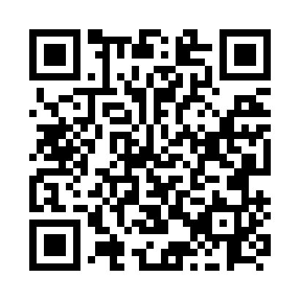
Prayer times for Bruxelles, Manitoba, Canada
Wed 1 May 2024 - Fri 31 May 2024
High Latitude Method: Angle Based Rule
Prayer Calculation Method: Islamic Society of North America
Asar Calculation Method: Hanafi

Date | Day | Fajr | Sunrise | Dhuhr | Asr | Maghrib | Isha
1 | Wed | 4:24 | 6:12 | 1:33 | 6:38 | 8:54 | 10:43
2 | Thu | 4:22 | 6:11 | 1:33 | 6:39 | 8:55 | 10:45
3 | Fri | 4:19 | 6:09 | 1:32 | 6:40 | 8:57 | 10:47
4 | Sat | 4:16 | 6:07 | 1:32 | 6:41 | 8:58 | 10:50
5 | Sun | 4:14 | 6:06 | 1:32 | 6:42 | 9:00 | 10:52
6 | Mon | 4:11 | 6:04 | 1:32 | 6:43 | 9:01 | 10:54
7 | Tue | 4:09 | 6:02 | 1:32 | 6:43 | 9:03 | 10:57
8 | Wed | 4:07 | 6:01 | 1:32 | 6:44 | 9:04 | 10:59
9 | Thu | 4:04 | 5:59 | 1:32 | 6:45 | 9:06 | 11:01
10 | Fri | 4:02 | 5:58 | 1:32 | 6:46 | 9:07 | 11:04
11 | Sat | 3:59 | 5:56 | 1:32 | 6:47 | 9:09 | 11:06
12 | Sun | 3:57 | 5:55 | 1:32 | 6:48 | 9:10 | 11:09
13 | Mon | 3:54 | 5:53 | 1:32 | 6:49 | 9:11 | 11:11
14 | Tue | 3:52 | 5:52 | 1:32 | 6:49 | 9:13 | 11:13
15 | Wed | 3:49 | 5:51 | 1:32 | 6:50 | 9:14 | 11:16
16 | Thu | 3:47 | 5:49 | 1:32 | 6:51 | 9:15 | 11:18
17 | Fri | 3:45 | 5:48 | 1:32 | 6:52 | 9:17 | 11:21
18 | Sat | 3:42 | 5:47 | 1:32 | 6:53 | 9:18 | 11:23
19 | Sun | 3:40 | 5:46 | 1:32 | 6:53 | 9:19 | 11:26
20 | Mon | 3:39 | 5:44 | 1:32 | 6:54 | 9:21 | 11:27
21 | Tue | 3:38 | 5:43 | 1:32 | 6:55 | 9:22 | 11:27
22 | Wed | 3:37 | 5:42 | 1:32 | 6:56 | 9:23 | 11:28
23 | Thu | 3:37 | 5:41 | 1:33 | 6:56 | 9:24 | 11:29
24 | Fri | 3:37 | 5:40 | 1:33 | 6:57 | 9:26 | 11:29
25 | Sat | 3:36 | 5:39 | 1:33 | 6:58 | 9:27 | 11:30
26 | Sun | 3:36 | 5:38 | 1:33 | 6:58 | 9:28 | 11:31
27 | Mon | 3:35 | 5:37 | 1:33 | 6:59 | 9:29 | 11:31
28 | Tue | 3:35 | 5:36 | 1:33 | 7:00 | 9:30 | 11:32
29 | Wed | 3:35 | 5:36 | 1:33 | 7:00 | 9:31 | 11:32
30 | Thu | 3:34 | 5:35 | 1:33 | 7:01 | 9:32 | 11:33
31 | Fri | 3:34 | 5:34 | 1:34 | 7:02 | 9:33 | 11:34
Prayer times provided by https://www.salahtimes.com

