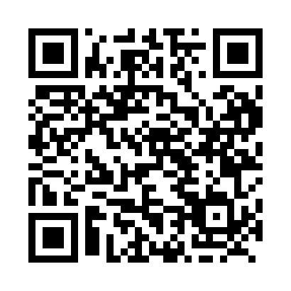
Prayer times for Tusket, Nova Scotia, Canada
Wed 1 May 2024 - Fri 31 May 2024
High Latitude Method: Angle Based Rule
Prayer Calculation Method: Islamic Society of North America
Asar Calculation Method: Hanafi

Date | Day | Fajr | Sunrise | Dhuhr | Asr | Maghrib | Isha
1 | Wed | 4:43 | 6:15 | 1:21 | 6:20 | 8:27 | 9:59
2 | Thu | 4:42 | 6:14 | 1:21 | 6:21 | 8:29 | 10:01
3 | Fri | 4:40 | 6:12 | 1:21 | 6:22 | 8:30 | 10:03
4 | Sat | 4:38 | 6:11 | 1:21 | 6:22 | 8:31 | 10:04
5 | Sun | 4:36 | 6:10 | 1:21 | 6:23 | 8:32 | 10:06
6 | Mon | 4:34 | 6:08 | 1:20 | 6:24 | 8:33 | 10:08
7 | Tue | 4:32 | 6:07 | 1:20 | 6:24 | 8:34 | 10:09
8 | Wed | 4:31 | 6:06 | 1:20 | 6:25 | 8:36 | 10:11
9 | Thu | 4:29 | 6:04 | 1:20 | 6:26 | 8:37 | 10:13
10 | Fri | 4:27 | 6:03 | 1:20 | 6:26 | 8:38 | 10:14
11 | Sat | 4:26 | 6:02 | 1:20 | 6:27 | 8:39 | 10:16
12 | Sun | 4:24 | 6:01 | 1:20 | 6:28 | 8:40 | 10:18
13 | Mon | 4:22 | 6:00 | 1:20 | 6:28 | 8:41 | 10:19
14 | Tue | 4:21 | 5:59 | 1:20 | 6:29 | 8:42 | 10:21
15 | Wed | 4:19 | 5:58 | 1:20 | 6:30 | 8:43 | 10:22
16 | Thu | 4:17 | 5:57 | 1:20 | 6:30 | 8:45 | 10:24
17 | Fri | 4:16 | 5:56 | 1:20 | 6:31 | 8:46 | 10:26
18 | Sat | 4:14 | 5:55 | 1:20 | 6:31 | 8:47 | 10:27
19 | Sun | 4:13 | 5:54 | 1:20 | 6:32 | 8:48 | 10:29
20 | Mon | 4:12 | 5:53 | 1:20 | 6:33 | 8:49 | 10:30
21 | Tue | 4:10 | 5:52 | 1:21 | 6:33 | 8:50 | 10:32
22 | Wed | 4:09 | 5:51 | 1:21 | 6:34 | 8:51 | 10:33
23 | Thu | 4:07 | 5:50 | 1:21 | 6:34 | 8:52 | 10:35
24 | Fri | 4:06 | 5:49 | 1:21 | 6:35 | 8:53 | 10:36
25 | Sat | 4:05 | 5:49 | 1:21 | 6:36 | 8:54 | 10:38
26 | Sun | 4:04 | 5:48 | 1:21 | 6:36 | 8:55 | 10:39
27 | Mon | 4:02 | 5:47 | 1:21 | 6:37 | 8:56 | 10:40
28 | Tue | 4:01 | 5:47 | 1:21 | 6:37 | 8:56 | 10:42
29 | Wed | 4:00 | 5:46 | 1:21 | 6:38 | 8:57 | 10:43
30 | Thu | 3:59 | 5:45 | 1:22 | 6:38 | 8:58 | 10:44
31 | Fri | 3:58 | 5:45 | 1:22 | 6:39 | 8:59 | 10:46
Prayer times provided by https://www.salahtimes.com

