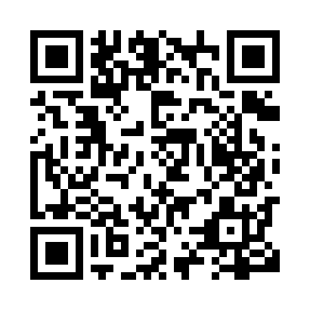
Prayer times for Halifax, Nova Scotia, Canada
Mon 1 Apr 2024 - Tue 30 Apr 2024
High Latitude Method: Angle Based Rule
Prayer Calculation Method: Islamic Society of North America
Asar Calculation Method: Hanafi

Date | Day | Fajr | Sunrise | Dhuhr | Asr | Maghrib | Isha
1 | Mon | 5:32 | 6:54 | 1:18 | 5:48 | 7:43 | 9:05
2 | Tue | 5:30 | 6:52 | 1:18 | 5:48 | 7:44 | 9:07
3 | Wed | 5:28 | 6:51 | 1:17 | 5:49 | 7:45 | 9:08
4 | Thu | 5:25 | 6:49 | 1:17 | 5:50 | 7:46 | 9:10
5 | Fri | 5:23 | 6:47 | 1:17 | 5:51 | 7:48 | 9:11
6 | Sat | 5:21 | 6:45 | 1:17 | 5:52 | 7:49 | 9:13
7 | Sun | 5:19 | 6:43 | 1:16 | 5:53 | 7:50 | 9:14
8 | Mon | 5:17 | 6:42 | 1:16 | 5:54 | 7:51 | 9:16
9 | Tue | 5:15 | 6:40 | 1:16 | 5:54 | 7:52 | 9:17
10 | Wed | 5:13 | 6:38 | 1:16 | 5:55 | 7:54 | 9:19
11 | Thu | 5:11 | 6:36 | 1:15 | 5:56 | 7:55 | 9:21
12 | Fri | 5:09 | 6:34 | 1:15 | 5:57 | 7:56 | 9:22
13 | Sat | 5:07 | 6:33 | 1:15 | 5:58 | 7:57 | 9:24
14 | Sun | 5:05 | 6:31 | 1:14 | 5:58 | 7:59 | 9:25
15 | Mon | 5:03 | 6:29 | 1:14 | 5:59 | 8:00 | 9:27
16 | Tue | 5:01 | 6:28 | 1:14 | 6:00 | 8:01 | 9:29
17 | Wed | 4:58 | 6:26 | 1:14 | 6:01 | 8:02 | 9:30
18 | Thu | 4:56 | 6:24 | 1:14 | 6:02 | 8:04 | 9:32
19 | Fri | 4:54 | 6:22 | 1:13 | 6:02 | 8:05 | 9:33
20 | Sat | 4:52 | 6:21 | 1:13 | 6:03 | 8:06 | 9:35
21 | Sun | 4:50 | 6:19 | 1:13 | 6:04 | 8:07 | 9:37
22 | Mon | 4:48 | 6:18 | 1:13 | 6:05 | 8:09 | 9:38
23 | Tue | 4:46 | 6:16 | 1:13 | 6:05 | 8:10 | 9:40
24 | Wed | 4:44 | 6:14 | 1:12 | 6:06 | 8:11 | 9:42
25 | Thu | 4:42 | 6:13 | 1:12 | 6:07 | 8:12 | 9:43
26 | Fri | 4:40 | 6:11 | 1:12 | 6:08 | 8:14 | 9:45
27 | Sat | 4:38 | 6:10 | 1:12 | 6:08 | 8:15 | 9:47
28 | Sun | 4:36 | 6:08 | 1:12 | 6:09 | 8:16 | 9:48
29 | Mon | 4:34 | 6:07 | 1:12 | 6:10 | 8:17 | 9:50
30 | Tue | 4:32 | 6:05 | 1:12 | 6:11 | 8:19 | 9:52
Prayer times provided by https://www.salahtimes.com

