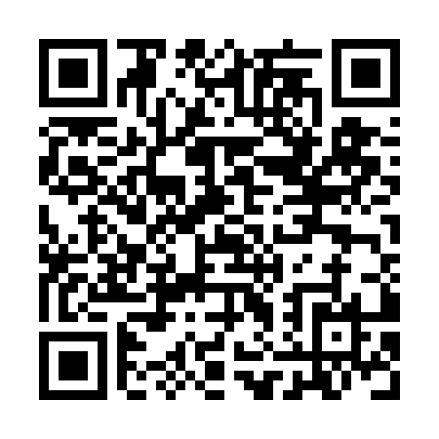
Prayer times for Unterbleichen, Germany
Wed 1 May 2024 - Fri 31 May 2024
High Latitude Method: Angle Based Rule
Prayer Calculation Method: Muslim World League
Asar Calculation Method: Shafi

Date | Day | Fajr | Sunrise | Dhuhr | Asr | Maghrib | Isha
1 | Wed | 3:48 | 5:59 | 1:16 | 5:15 | 8:33 | 10:35
2 | Thu | 3:46 | 5:58 | 1:16 | 5:16 | 8:34 | 10:37
3 | Fri | 3:43 | 5:56 | 1:16 | 5:17 | 8:36 | 10:40
4 | Sat | 3:40 | 5:54 | 1:15 | 5:17 | 8:37 | 10:42
5 | Sun | 3:37 | 5:53 | 1:15 | 5:18 | 8:39 | 10:45
6 | Mon | 3:35 | 5:51 | 1:15 | 5:18 | 8:40 | 10:47
7 | Tue | 3:32 | 5:50 | 1:15 | 5:19 | 8:41 | 10:49
8 | Wed | 3:29 | 5:48 | 1:15 | 5:19 | 8:43 | 10:52
9 | Thu | 3:27 | 5:47 | 1:15 | 5:20 | 8:44 | 10:54
10 | Fri | 3:24 | 5:45 | 1:15 | 5:20 | 8:46 | 10:57
11 | Sat | 3:21 | 5:44 | 1:15 | 5:21 | 8:47 | 10:59
12 | Sun | 3:18 | 5:42 | 1:15 | 5:21 | 8:48 | 11:02
13 | Mon | 3:16 | 5:41 | 1:15 | 5:22 | 8:50 | 11:04
14 | Tue | 3:13 | 5:40 | 1:15 | 5:22 | 8:51 | 11:07
15 | Wed | 3:10 | 5:38 | 1:15 | 5:23 | 8:52 | 11:09
16 | Thu | 3:07 | 5:37 | 1:15 | 5:23 | 8:54 | 11:12
17 | Fri | 3:05 | 5:36 | 1:15 | 5:24 | 8:55 | 11:14
18 | Sat | 3:02 | 5:35 | 1:15 | 5:24 | 8:56 | 11:17
19 | Sun | 2:59 | 5:34 | 1:15 | 5:25 | 8:57 | 11:20
20 | Mon | 2:58 | 5:33 | 1:15 | 5:25 | 8:59 | 11:22
21 | Tue | 2:58 | 5:31 | 1:15 | 5:26 | 9:00 | 11:25
22 | Wed | 2:58 | 5:30 | 1:15 | 5:26 | 9:01 | 11:25
23 | Thu | 2:57 | 5:29 | 1:15 | 5:26 | 9:02 | 11:26
24 | Fri | 2:57 | 5:28 | 1:16 | 5:27 | 9:03 | 11:26
25 | Sat | 2:57 | 5:27 | 1:16 | 5:27 | 9:04 | 11:27
26 | Sun | 2:56 | 5:27 | 1:16 | 5:28 | 9:06 | 11:27
27 | Mon | 2:56 | 5:26 | 1:16 | 5:28 | 9:07 | 11:28
28 | Tue | 2:56 | 5:25 | 1:16 | 5:29 | 9:08 | 11:29
29 | Wed | 2:55 | 5:24 | 1:16 | 5:29 | 9:09 | 11:29
30 | Thu | 2:55 | 5:23 | 1:16 | 5:30 | 9:10 | 11:30
31 | Fri | 2:55 | 5:23 | 1:16 | 5:30 | 9:11 | 11:30
Prayer times provided by https://www.salahtimes.com

