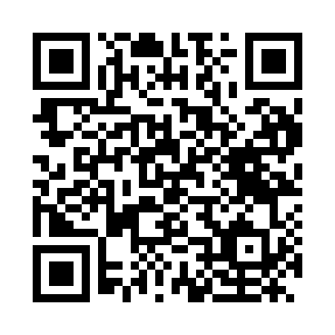
Prayer times for Gibara, Cuba
Wed 1 May 2024 - Fri 31 May 2024
High Latitude Method: None
Prayer Calculation Method: Muslim World League
Asar Calculation Method: Shafi

Date | Day | Fajr | Sunrise | Dhuhr | Asr | Maghrib | Isha
1 | Wed | 5:15 | 6:34 | 1:02 | 4:22 | 7:30 | 8:44
2 | Thu | 5:14 | 6:33 | 1:01 | 4:22 | 7:30 | 8:44
3 | Fri | 5:13 | 6:32 | 1:01 | 4:21 | 7:31 | 8:45
4 | Sat | 5:13 | 6:32 | 1:01 | 4:21 | 7:31 | 8:46
5 | Sun | 5:12 | 6:31 | 1:01 | 4:20 | 7:31 | 8:46
6 | Mon | 5:11 | 6:31 | 1:01 | 4:20 | 7:32 | 8:47
7 | Tue | 5:10 | 6:30 | 1:01 | 4:20 | 7:32 | 8:47
8 | Wed | 5:10 | 6:30 | 1:01 | 4:19 | 7:33 | 8:48
9 | Thu | 5:09 | 6:29 | 1:01 | 4:19 | 7:33 | 8:48
10 | Fri | 5:08 | 6:29 | 1:01 | 4:19 | 7:33 | 8:49
11 | Sat | 5:08 | 6:28 | 1:01 | 4:18 | 7:34 | 8:50
12 | Sun | 5:07 | 6:28 | 1:01 | 4:18 | 7:34 | 8:50
13 | Mon | 5:06 | 6:27 | 1:01 | 4:18 | 7:35 | 8:51
14 | Tue | 5:06 | 6:27 | 1:01 | 4:18 | 7:35 | 8:51
15 | Wed | 5:05 | 6:26 | 1:01 | 4:17 | 7:36 | 8:52
16 | Thu | 5:05 | 6:26 | 1:01 | 4:17 | 7:36 | 8:53
17 | Fri | 5:04 | 6:26 | 1:01 | 4:17 | 7:36 | 8:53
18 | Sat | 5:04 | 6:25 | 1:01 | 4:17 | 7:37 | 8:54
19 | Sun | 5:03 | 6:25 | 1:01 | 4:16 | 7:37 | 8:54
20 | Mon | 5:03 | 6:25 | 1:01 | 4:16 | 7:38 | 8:55
21 | Tue | 5:02 | 6:24 | 1:01 | 4:16 | 7:38 | 8:55
22 | Wed | 5:02 | 6:24 | 1:01 | 4:16 | 7:39 | 8:56
23 | Thu | 5:01 | 6:24 | 1:01 | 4:16 | 7:39 | 8:57
24 | Fri | 5:01 | 6:24 | 1:01 | 4:15 | 7:39 | 8:57
25 | Sat | 5:01 | 6:23 | 1:02 | 4:15 | 7:40 | 8:58
26 | Sun | 5:00 | 6:23 | 1:02 | 4:16 | 7:40 | 8:58
27 | Mon | 5:00 | 6:23 | 1:02 | 4:17 | 7:41 | 8:59
28 | Tue | 5:00 | 6:23 | 1:02 | 4:17 | 7:41 | 8:59
29 | Wed | 4:59 | 6:23 | 1:02 | 4:18 | 7:42 | 9:00
30 | Thu | 4:59 | 6:23 | 1:02 | 4:18 | 7:42 | 9:00
31 | Fri | 4:59 | 6:22 | 1:02 | 4:19 | 7:42 | 9:01
Prayer times provided by https://www.salahtimes.com

