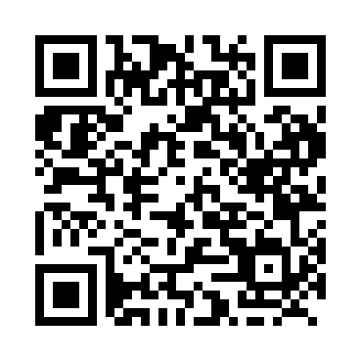
Prayer times for Brooks Brook, Yukon, Canada
Wed 1 May 2024 - Fri 31 May 2024
High Latitude Method: Angle Based Rule
Prayer Calculation Method: Islamic Society of North America
Asar Calculation Method: Hanafi

Date | Day | Fajr | Sunrise | Dhuhr | Asr | Maghrib | Isha
1 | Wed | 3:48 | 5:46 | 1:50 | 7:09 | 9:55 | 11:53
2 | Thu | 3:47 | 5:43 | 1:50 | 7:10 | 9:57 | 11:54
3 | Fri | 3:45 | 5:41 | 1:50 | 7:12 | 10:00 | 11:55
4 | Sat | 3:44 | 5:38 | 1:49 | 7:13 | 10:02 | 11:56
5 | Sun | 3:43 | 5:35 | 1:49 | 7:15 | 10:05 | 11:57
6 | Mon | 3:41 | 5:33 | 1:49 | 7:16 | 10:07 | 11:59
7 | Tue | 3:40 | 5:30 | 1:49 | 7:17 | 10:10 | 12:00
8 | Wed | 3:39 | 5:27 | 1:49 | 7:19 | 10:12 | 12:01
9 | Thu | 3:37 | 5:25 | 1:49 | 7:20 | 10:15 | 12:02
10 | Fri | 3:36 | 5:22 | 1:49 | 7:21 | 10:17 | 12:04
11 | Sat | 3:35 | 5:20 | 1:49 | 7:23 | 10:20 | 12:05
12 | Sun | 3:33 | 5:17 | 1:49 | 7:24 | 10:22 | 12:06
13 | Mon | 3:32 | 5:15 | 1:49 | 7:25 | 10:25 | 12:07
14 | Tue | 3:31 | 5:12 | 1:49 | 7:27 | 10:27 | 12:08
15 | Wed | 3:30 | 5:10 | 1:49 | 7:28 | 10:30 | 12:10
16 | Thu | 3:29 | 5:08 | 1:49 | 7:29 | 10:32 | 12:11
17 | Fri | 3:28 | 5:05 | 1:49 | 7:30 | 10:34 | 12:12
18 | Sat | 3:26 | 5:03 | 1:49 | 7:32 | 10:37 | 12:13
19 | Sun | 3:25 | 5:01 | 1:49 | 7:33 | 10:39 | 12:14
20 | Mon | 3:24 | 4:59 | 1:49 | 7:34 | 10:41 | 12:16
21 | Tue | 3:23 | 4:56 | 1:49 | 7:35 | 10:44 | 12:17
22 | Wed | 3:22 | 4:54 | 1:50 | 7:36 | 10:46 | 12:18
23 | Thu | 3:21 | 4:52 | 1:50 | 7:37 | 10:48 | 12:19
24 | Fri | 3:20 | 4:50 | 1:50 | 7:39 | 10:50 | 12:20
25 | Sat | 3:19 | 4:48 | 1:50 | 7:40 | 10:52 | 12:21
26 | Sun | 3:18 | 4:46 | 1:50 | 7:41 | 10:54 | 12:22
27 | Mon | 3:18 | 4:45 | 1:50 | 7:42 | 10:56 | 12:23
28 | Tue | 3:17 | 4:43 | 1:50 | 7:43 | 10:58 | 12:25
29 | Wed | 3:16 | 4:41 | 1:50 | 7:44 | 11:00 | 12:26
30 | Thu | 3:15 | 4:40 | 1:50 | 7:44 | 11:02 | 12:27
31 | Fri | 3:15 | 4:38 | 1:51 | 7:45 | 11:04 | 12:28
Prayer times provided by https://www.salahtimes.com

