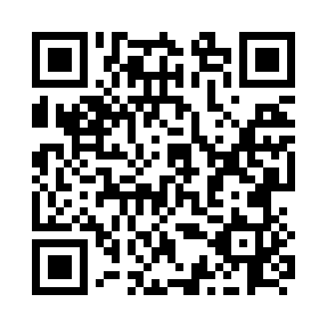
Prayer times for Sterco, Alberta, Canada
Mon 1 Jul 2024 - Wed 31 Jul 2024
High Latitude Method: Angle Based Rule
Prayer Calculation Method: Islamic Society of North America
Asar Calculation Method: Hanafi

Date | Day | Fajr | Sunrise | Dhuhr | Asr | Maghrib | Isha
1 | Mon | 3:39 | 5:26 | 1:51 | 7:31 | 10:17 | 12:04
2 | Tue | 3:39 | 5:27 | 1:52 | 7:31 | 10:16 | 12:04
3 | Wed | 3:40 | 5:27 | 1:52 | 7:31 | 10:16 | 12:04
4 | Thu | 3:40 | 5:28 | 1:52 | 7:31 | 10:15 | 12:03
5 | Fri | 3:41 | 5:29 | 1:52 | 7:30 | 10:14 | 12:03
6 | Sat | 3:41 | 5:30 | 1:52 | 7:30 | 10:14 | 12:03
7 | Sun | 3:42 | 5:31 | 1:52 | 7:30 | 10:13 | 12:03
8 | Mon | 3:42 | 5:32 | 1:53 | 7:30 | 10:12 | 12:02
9 | Tue | 3:43 | 5:33 | 1:53 | 7:29 | 10:11 | 12:02
10 | Wed | 3:44 | 5:35 | 1:53 | 7:29 | 10:11 | 12:02
11 | Thu | 3:44 | 5:36 | 1:53 | 7:28 | 10:10 | 12:01
12 | Fri | 3:45 | 5:37 | 1:53 | 7:28 | 10:09 | 12:01
13 | Sat | 3:45 | 5:38 | 1:53 | 7:27 | 10:08 | 12:00
14 | Sun | 3:46 | 5:39 | 1:53 | 7:27 | 10:07 | 12:00
15 | Mon | 3:47 | 5:41 | 1:53 | 7:26 | 10:06 | 11:59
16 | Tue | 3:48 | 5:42 | 1:53 | 7:26 | 10:04 | 11:59
17 | Wed | 3:48 | 5:43 | 1:54 | 7:25 | 10:03 | 11:58
18 | Thu | 3:49 | 5:45 | 1:54 | 7:25 | 10:02 | 11:58
19 | Fri | 3:50 | 5:46 | 1:54 | 7:24 | 10:01 | 11:57
20 | Sat | 3:50 | 5:47 | 1:54 | 7:23 | 9:59 | 11:56
21 | Sun | 3:51 | 5:49 | 1:54 | 7:22 | 9:58 | 11:56
22 | Mon | 3:52 | 5:50 | 1:54 | 7:22 | 9:57 | 11:55
23 | Tue | 3:53 | 5:52 | 1:54 | 7:21 | 9:55 | 11:54
24 | Wed | 3:53 | 5:53 | 1:54 | 7:20 | 9:54 | 11:54
25 | Thu | 3:54 | 5:55 | 1:54 | 7:19 | 9:52 | 11:53
26 | Fri | 3:55 | 5:56 | 1:54 | 7:18 | 9:51 | 11:52
27 | Sat | 3:56 | 5:58 | 1:54 | 7:17 | 9:49 | 11:51
28 | Sun | 3:56 | 5:59 | 1:54 | 7:16 | 9:47 | 11:50
29 | Mon | 3:57 | 6:01 | 1:54 | 7:15 | 9:46 | 11:49
30 | Tue | 3:58 | 6:03 | 1:54 | 7:14 | 9:44 | 11:49
31 | Wed | 3:59 | 6:04 | 1:54 | 7:13 | 9:42 | 11:48
Prayer times provided by https://www.salahtimes.com

