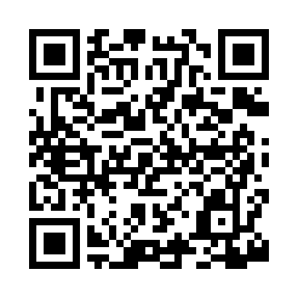
Prayer times for Lake Elmore, Vermont, USA
Mon 1 Jul 2024 - Wed 31 Jul 2024
High Latitude Method: Angle Based Rule
Prayer Calculation Method: Islamic Society of North America
Asar Calculation Method: Shafi

Date | Day | Fajr | Sunrise | Dhuhr | Asr | Maghrib | Isha
1 | Mon | 3:16 | 5:09 | 12:54 | 5:02 | 8:39 | 10:32
2 | Tue | 3:17 | 5:10 | 12:54 | 5:02 | 8:38 | 10:31
3 | Wed | 3:18 | 5:11 | 12:55 | 5:02 | 8:38 | 10:30
4 | Thu | 3:19 | 5:11 | 12:55 | 5:02 | 8:38 | 10:30
5 | Fri | 3:20 | 5:12 | 12:55 | 5:02 | 8:38 | 10:29
6 | Sat | 3:21 | 5:13 | 12:55 | 5:02 | 8:37 | 10:28
7 | Sun | 3:22 | 5:13 | 12:55 | 5:02 | 8:37 | 10:27
8 | Mon | 3:23 | 5:14 | 12:55 | 5:02 | 8:36 | 10:27
9 | Tue | 3:25 | 5:15 | 12:55 | 5:02 | 8:36 | 10:26
10 | Wed | 3:26 | 5:16 | 12:56 | 5:02 | 8:35 | 10:25
11 | Thu | 3:27 | 5:16 | 12:56 | 5:02 | 8:35 | 10:24
12 | Fri | 3:28 | 5:17 | 12:56 | 5:02 | 8:34 | 10:23
13 | Sat | 3:30 | 5:18 | 12:56 | 5:02 | 8:33 | 10:21
14 | Sun | 3:31 | 5:19 | 12:56 | 5:02 | 8:33 | 10:20
15 | Mon | 3:33 | 5:20 | 12:56 | 5:02 | 8:32 | 10:19
16 | Tue | 3:34 | 5:21 | 12:56 | 5:01 | 8:31 | 10:18
17 | Wed | 3:35 | 5:22 | 12:56 | 5:01 | 8:30 | 10:16
18 | Thu | 3:37 | 5:23 | 12:56 | 5:01 | 8:30 | 10:15
19 | Fri | 3:38 | 5:24 | 12:56 | 5:01 | 8:29 | 10:14
20 | Sat | 3:40 | 5:25 | 12:57 | 5:01 | 8:28 | 10:12
21 | Sun | 3:42 | 5:26 | 12:57 | 5:00 | 8:27 | 10:11
22 | Mon | 3:43 | 5:27 | 12:57 | 5:00 | 8:26 | 10:09
23 | Tue | 3:45 | 5:28 | 12:57 | 5:00 | 8:25 | 10:08
24 | Wed | 3:46 | 5:29 | 12:57 | 5:00 | 8:24 | 10:06
25 | Thu | 3:48 | 5:30 | 12:57 | 4:59 | 8:23 | 10:05
26 | Fri | 3:49 | 5:31 | 12:57 | 4:59 | 8:22 | 10:03
27 | Sat | 3:51 | 5:32 | 12:57 | 4:59 | 8:21 | 10:01
28 | Sun | 3:53 | 5:33 | 12:57 | 4:58 | 8:20 | 10:00
29 | Mon | 3:54 | 5:34 | 12:57 | 4:58 | 8:18 | 9:58
30 | Tue | 3:56 | 5:35 | 12:57 | 4:57 | 8:17 | 9:56
31 | Wed | 3:58 | 5:36 | 12:56 | 4:57 | 8:16 | 9:54
Prayer times provided by https://www.salahtimes.com

