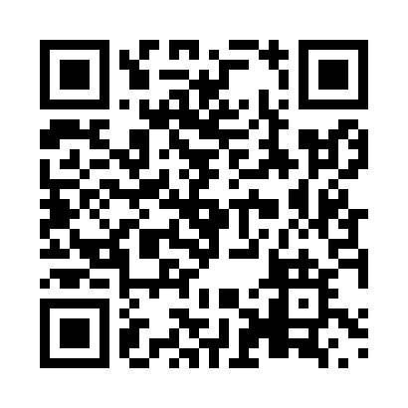
Prayer times for The Slash, Ontario, Canada
Mon 1 Apr 2024 - Tue 30 Apr 2024
High Latitude Method: Angle Based Rule
Prayer Calculation Method: Islamic Society of North America
Asar Calculation Method: Hanafi

Date | Day | Fajr | Sunrise | Dhuhr | Asr | Maghrib | Isha
1 | Mon | 5:43 | 7:07 | 1:32 | 6:01 | 7:57 | 9:21
2 | Tue | 5:41 | 7:05 | 1:31 | 6:02 | 7:58 | 9:23
3 | Wed | 5:38 | 7:03 | 1:31 | 6:03 | 7:59 | 9:24
4 | Thu | 5:36 | 7:01 | 1:31 | 6:04 | 8:01 | 9:26
5 | Fri | 5:34 | 6:59 | 1:30 | 6:04 | 8:02 | 9:28
6 | Sat | 5:32 | 6:58 | 1:30 | 6:05 | 8:03 | 9:29
7 | Sun | 5:30 | 6:56 | 1:30 | 6:06 | 8:05 | 9:31
8 | Mon | 5:28 | 6:54 | 1:30 | 6:07 | 8:06 | 9:32
9 | Tue | 5:25 | 6:52 | 1:29 | 6:08 | 8:07 | 9:34
10 | Wed | 5:23 | 6:50 | 1:29 | 6:09 | 8:09 | 9:36
11 | Thu | 5:21 | 6:48 | 1:29 | 6:10 | 8:10 | 9:37
12 | Fri | 5:19 | 6:47 | 1:28 | 6:11 | 8:11 | 9:39
13 | Sat | 5:17 | 6:45 | 1:28 | 6:11 | 8:12 | 9:41
14 | Sun | 5:15 | 6:43 | 1:28 | 6:12 | 8:14 | 9:42
15 | Mon | 5:13 | 6:41 | 1:28 | 6:13 | 8:15 | 9:44
16 | Tue | 5:10 | 6:39 | 1:27 | 6:14 | 8:16 | 9:46
17 | Wed | 5:08 | 6:38 | 1:27 | 6:15 | 8:18 | 9:47
18 | Thu | 5:06 | 6:36 | 1:27 | 6:16 | 8:19 | 9:49
19 | Fri | 5:04 | 6:34 | 1:27 | 6:16 | 8:20 | 9:51
20 | Sat | 5:02 | 6:32 | 1:27 | 6:17 | 8:22 | 9:52
21 | Sun | 5:00 | 6:31 | 1:26 | 6:18 | 8:23 | 9:54
22 | Mon | 4:58 | 6:29 | 1:26 | 6:19 | 8:24 | 9:56
23 | Tue | 4:55 | 6:27 | 1:26 | 6:20 | 8:25 | 9:58
24 | Wed | 4:53 | 6:26 | 1:26 | 6:21 | 8:27 | 9:59
25 | Thu | 4:51 | 6:24 | 1:26 | 6:21 | 8:28 | 10:01
26 | Fri | 4:49 | 6:23 | 1:26 | 6:22 | 8:29 | 10:03
27 | Sat | 4:47 | 6:21 | 1:25 | 6:23 | 8:31 | 10:05
28 | Sun | 4:45 | 6:19 | 1:25 | 6:24 | 8:32 | 10:07
29 | Mon | 4:43 | 6:18 | 1:25 | 6:24 | 8:33 | 10:08
30 | Tue | 4:41 | 6:16 | 1:25 | 6:25 | 8:34 | 10:10
Prayer times provided by https://www.salahtimes.com

