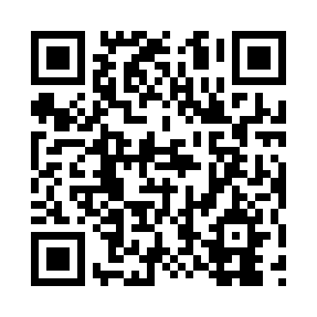
Prayer times for Trinum, Germany
Wed 1 May 2024 - Fri 31 May 2024
High Latitude Method: Angle Based Rule
Prayer Calculation Method: Muslim World League
Asar Calculation Method: Shafi

Date | Day | Fajr | Sunrise | Dhuhr | Asr | Maghrib | Isha
1 | Wed | 3:11 | 5:43 | 1:09 | 5:13 | 8:37 | 10:58
2 | Thu | 3:07 | 5:41 | 1:09 | 5:13 | 8:39 | 11:01
3 | Fri | 3:03 | 5:39 | 1:09 | 5:14 | 8:40 | 11:04
4 | Sat | 3:00 | 5:37 | 1:09 | 5:15 | 8:42 | 11:07
5 | Sun | 2:56 | 5:35 | 1:09 | 5:15 | 8:44 | 11:11
6 | Mon | 2:55 | 5:33 | 1:09 | 5:16 | 8:45 | 11:14
7 | Tue | 2:54 | 5:32 | 1:09 | 5:17 | 8:47 | 11:16
8 | Wed | 2:54 | 5:30 | 1:09 | 5:17 | 8:49 | 11:16
9 | Thu | 2:53 | 5:28 | 1:09 | 5:18 | 8:50 | 11:17
10 | Fri | 2:52 | 5:27 | 1:09 | 5:19 | 8:52 | 11:18
11 | Sat | 2:51 | 5:25 | 1:09 | 5:19 | 8:53 | 11:18
12 | Sun | 2:51 | 5:23 | 1:09 | 5:20 | 8:55 | 11:19
13 | Mon | 2:50 | 5:22 | 1:09 | 5:20 | 8:56 | 11:20
14 | Tue | 2:50 | 5:20 | 1:09 | 5:21 | 8:58 | 11:20
15 | Wed | 2:49 | 5:19 | 1:09 | 5:22 | 8:59 | 11:21
16 | Thu | 2:48 | 5:17 | 1:09 | 5:22 | 9:01 | 11:22
17 | Fri | 2:48 | 5:16 | 1:09 | 5:23 | 9:02 | 11:22
18 | Sat | 2:47 | 5:14 | 1:09 | 5:23 | 9:04 | 11:23
19 | Sun | 2:47 | 5:13 | 1:09 | 5:24 | 9:05 | 11:24
20 | Mon | 2:46 | 5:12 | 1:09 | 5:24 | 9:07 | 11:24
21 | Tue | 2:46 | 5:11 | 1:09 | 5:25 | 9:08 | 11:25
22 | Wed | 2:45 | 5:09 | 1:09 | 5:26 | 9:10 | 11:25
23 | Thu | 2:45 | 5:08 | 1:09 | 5:26 | 9:11 | 11:26
24 | Fri | 2:44 | 5:07 | 1:09 | 5:27 | 9:12 | 11:27
25 | Sat | 2:44 | 5:06 | 1:09 | 5:27 | 9:14 | 11:27
26 | Sun | 2:44 | 5:05 | 1:09 | 5:28 | 9:15 | 11:28
27 | Mon | 2:43 | 5:04 | 1:10 | 5:28 | 9:16 | 11:29
28 | Tue | 2:43 | 5:03 | 1:10 | 5:29 | 9:17 | 11:29
29 | Wed | 2:43 | 5:02 | 1:10 | 5:29 | 9:19 | 11:30
30 | Thu | 2:42 | 5:01 | 1:10 | 5:30 | 9:20 | 11:30
31 | Fri | 2:42 | 5:00 | 1:10 | 5:30 | 9:21 | 11:31
Prayer times provided by https://www.salahtimes.com

