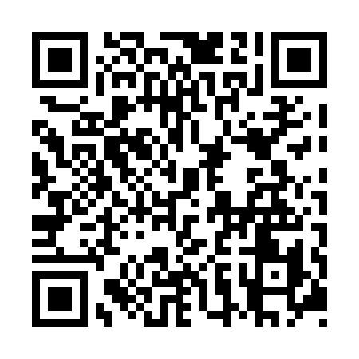
Prayer times for Cleveland Park, British Columbia, Canada
Mon 1 Apr 2024 - Tue 30 Apr 2024
High Latitude Method: Angle Based Rule
Prayer Calculation Method: Islamic Society of North America
Asar Calculation Method: Hanafi

Date | Day | Fajr | Sunrise | Dhuhr | Asr | Maghrib | Isha
1 | Mon | 5:17 | 6:48 | 1:16 | 5:44 | 7:45 | 9:17
2 | Tue | 5:14 | 6:46 | 1:16 | 5:46 | 7:46 | 9:18
3 | Wed | 5:12 | 6:44 | 1:15 | 5:47 | 7:48 | 9:20
4 | Thu | 5:09 | 6:42 | 1:15 | 5:48 | 7:49 | 9:22
5 | Fri | 5:07 | 6:40 | 1:15 | 5:49 | 7:51 | 9:24
6 | Sat | 5:04 | 6:38 | 1:15 | 5:50 | 7:52 | 9:26
7 | Sun | 5:02 | 6:35 | 1:14 | 5:51 | 7:54 | 9:28
8 | Mon | 4:59 | 6:33 | 1:14 | 5:52 | 7:56 | 9:30
9 | Tue | 4:57 | 6:31 | 1:14 | 5:53 | 7:57 | 9:32
10 | Wed | 4:54 | 6:29 | 1:13 | 5:54 | 7:59 | 9:34
11 | Thu | 4:52 | 6:27 | 1:13 | 5:55 | 8:00 | 9:36
12 | Fri | 4:49 | 6:25 | 1:13 | 5:56 | 8:02 | 9:38
13 | Sat | 4:47 | 6:23 | 1:13 | 5:57 | 8:03 | 9:40
14 | Sun | 4:44 | 6:21 | 1:12 | 5:58 | 8:05 | 9:42
15 | Mon | 4:42 | 6:19 | 1:12 | 5:59 | 8:06 | 9:44
16 | Tue | 4:39 | 6:17 | 1:12 | 6:00 | 8:08 | 9:46
17 | Wed | 4:37 | 6:15 | 1:12 | 6:01 | 8:09 | 9:48
18 | Thu | 4:34 | 6:13 | 1:12 | 6:02 | 8:11 | 9:50
19 | Fri | 4:32 | 6:11 | 1:11 | 6:03 | 8:12 | 9:52
20 | Sat | 4:29 | 6:09 | 1:11 | 6:04 | 8:14 | 9:54
21 | Sun | 4:27 | 6:07 | 1:11 | 6:05 | 8:15 | 9:57
22 | Mon | 4:24 | 6:06 | 1:11 | 6:06 | 8:17 | 9:59
23 | Tue | 4:22 | 6:04 | 1:11 | 6:07 | 8:18 | 10:01
24 | Wed | 4:19 | 6:02 | 1:10 | 6:08 | 8:20 | 10:03
25 | Thu | 4:17 | 6:00 | 1:10 | 6:09 | 8:21 | 10:05
26 | Fri | 4:14 | 5:58 | 1:10 | 6:10 | 8:23 | 10:07
27 | Sat | 4:11 | 5:56 | 1:10 | 6:11 | 8:24 | 10:10
28 | Sun | 4:09 | 5:54 | 1:10 | 6:12 | 8:26 | 10:12
29 | Mon | 4:06 | 5:53 | 1:10 | 6:13 | 8:27 | 10:14
30 | Tue | 4:04 | 5:51 | 1:10 | 6:14 | 8:29 | 10:16
Prayer times provided by https://www.salahtimes.com

