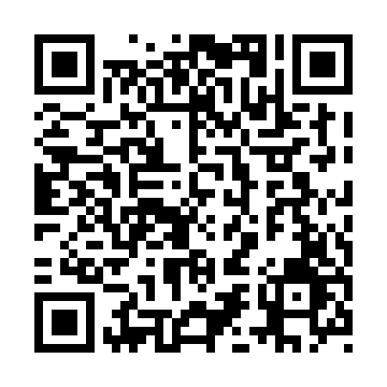
Prayer times for Cotnam Island, Ontario, Canada
Mon 1 Apr 2024 - Tue 30 Apr 2024
High Latitude Method: Angle Based Rule
Prayer Calculation Method: Islamic Society of North America
Asar Calculation Method: Hanafi

Date | Day | Fajr | Sunrise | Dhuhr | Asr | Maghrib | Isha
1 | Mon | 5:23 | 6:47 | 1:12 | 5:41 | 7:37 | 9:02
2 | Tue | 5:20 | 6:45 | 1:11 | 5:42 | 7:39 | 9:04
3 | Wed | 5:18 | 6:43 | 1:11 | 5:43 | 7:40 | 9:05
4 | Thu | 5:16 | 6:41 | 1:11 | 5:44 | 7:41 | 9:07
5 | Fri | 5:14 | 6:40 | 1:11 | 5:45 | 7:43 | 9:08
6 | Sat | 5:12 | 6:38 | 1:10 | 5:46 | 7:44 | 9:10
7 | Sun | 5:10 | 6:36 | 1:10 | 5:47 | 7:45 | 9:12
8 | Mon | 5:07 | 6:34 | 1:10 | 5:47 | 7:46 | 9:13
9 | Tue | 5:05 | 6:32 | 1:10 | 5:48 | 7:48 | 9:15
10 | Wed | 5:03 | 6:30 | 1:09 | 5:49 | 7:49 | 9:16
11 | Thu | 5:01 | 6:28 | 1:09 | 5:50 | 7:50 | 9:18
12 | Fri | 4:59 | 6:27 | 1:09 | 5:51 | 7:52 | 9:20
13 | Sat | 4:57 | 6:25 | 1:08 | 5:52 | 7:53 | 9:21
14 | Sun | 4:54 | 6:23 | 1:08 | 5:53 | 7:54 | 9:23
15 | Mon | 4:52 | 6:21 | 1:08 | 5:53 | 7:56 | 9:25
16 | Tue | 4:50 | 6:19 | 1:08 | 5:54 | 7:57 | 9:27
17 | Wed | 4:48 | 6:18 | 1:08 | 5:55 | 7:58 | 9:28
18 | Thu | 4:46 | 6:16 | 1:07 | 5:56 | 8:00 | 9:30
19 | Fri | 4:44 | 6:14 | 1:07 | 5:57 | 8:01 | 9:32
20 | Sat | 4:41 | 6:12 | 1:07 | 5:58 | 8:02 | 9:33
21 | Sun | 4:39 | 6:11 | 1:07 | 5:58 | 8:03 | 9:35
22 | Mon | 4:37 | 6:09 | 1:07 | 5:59 | 8:05 | 9:37
23 | Tue | 4:35 | 6:07 | 1:06 | 6:00 | 8:06 | 9:39
24 | Wed | 4:33 | 6:06 | 1:06 | 6:01 | 8:07 | 9:41
25 | Thu | 4:31 | 6:04 | 1:06 | 6:02 | 8:09 | 9:42
26 | Fri | 4:29 | 6:02 | 1:06 | 6:03 | 8:10 | 9:44
27 | Sat | 4:26 | 6:01 | 1:06 | 6:03 | 8:11 | 9:46
28 | Sun | 4:24 | 5:59 | 1:06 | 6:04 | 8:13 | 9:48
29 | Mon | 4:22 | 5:58 | 1:05 | 6:05 | 8:14 | 9:50
30 | Tue | 4:20 | 5:56 | 1:05 | 6:06 | 8:15 | 9:51
Prayer times provided by https://www.salahtimes.com

