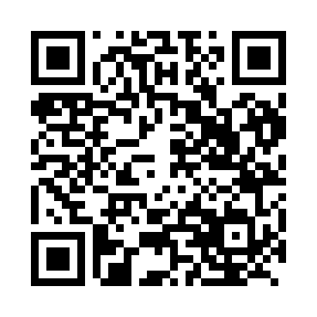
Prayer times for Bareto, Cameroon
Mon 1 Apr 2024 - Tue 30 Apr 2024
High Latitude Method: None
Prayer Calculation Method: Muslim World League
Asar Calculation Method: Shafi

Date | Day | Fajr | Sunrise | Dhuhr | Asr | Maghrib | Isha
1 | Mon | 4:55 | 6:04 | 12:08 | 3:13 | 6:12 | 7:17
2 | Tue | 4:54 | 6:03 | 12:07 | 3:13 | 6:12 | 7:17
3 | Wed | 4:54 | 6:03 | 12:07 | 3:13 | 6:11 | 7:16
4 | Thu | 4:53 | 6:03 | 12:07 | 3:14 | 6:11 | 7:16
5 | Fri | 4:53 | 6:02 | 12:07 | 3:14 | 6:11 | 7:16
6 | Sat | 4:53 | 6:02 | 12:06 | 3:15 | 6:11 | 7:16
7 | Sun | 4:52 | 6:02 | 12:06 | 3:15 | 6:11 | 7:16
8 | Mon | 4:52 | 6:01 | 12:06 | 3:15 | 6:10 | 7:16
9 | Tue | 4:51 | 6:01 | 12:05 | 3:16 | 6:10 | 7:16
10 | Wed | 4:51 | 6:01 | 12:05 | 3:16 | 6:10 | 7:15
11 | Thu | 4:51 | 6:00 | 12:05 | 3:16 | 6:10 | 7:15
12 | Fri | 4:50 | 6:00 | 12:05 | 3:16 | 6:10 | 7:15
13 | Sat | 4:50 | 6:00 | 12:04 | 3:17 | 6:09 | 7:15
14 | Sun | 4:49 | 5:59 | 12:04 | 3:17 | 6:09 | 7:15
15 | Mon | 4:49 | 5:59 | 12:04 | 3:17 | 6:09 | 7:15
16 | Tue | 4:49 | 5:59 | 12:04 | 3:18 | 6:09 | 7:15
17 | Wed | 4:48 | 5:58 | 12:03 | 3:18 | 6:09 | 7:15
18 | Thu | 4:48 | 5:58 | 12:03 | 3:18 | 6:08 | 7:15
19 | Fri | 4:48 | 5:58 | 12:03 | 3:18 | 6:08 | 7:15
20 | Sat | 4:47 | 5:57 | 12:03 | 3:19 | 6:08 | 7:14
21 | Sun | 4:47 | 5:57 | 12:03 | 3:19 | 6:08 | 7:14
22 | Mon | 4:46 | 5:57 | 12:02 | 3:19 | 6:08 | 7:14
23 | Tue | 4:46 | 5:57 | 12:02 | 3:19 | 6:08 | 7:14
24 | Wed | 4:46 | 5:56 | 12:02 | 3:19 | 6:08 | 7:14
25 | Thu | 4:45 | 5:56 | 12:02 | 3:20 | 6:08 | 7:14
26 | Fri | 4:45 | 5:56 | 12:02 | 3:20 | 6:07 | 7:14
27 | Sat | 4:45 | 5:56 | 12:02 | 3:20 | 6:07 | 7:14
28 | Sun | 4:44 | 5:56 | 12:01 | 3:20 | 6:07 | 7:14
29 | Mon | 4:44 | 5:55 | 12:01 | 3:20 | 6:07 | 7:14
30 | Tue | 4:44 | 5:55 | 12:01 | 3:21 | 6:07 | 7:14
Prayer times provided by https://www.salahtimes.com

