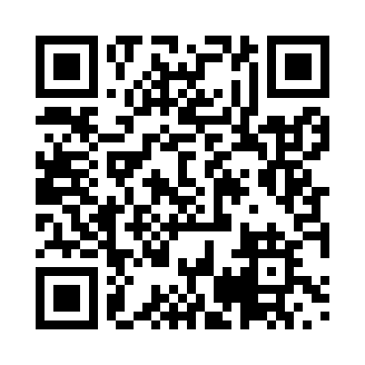
Prayer times for Bengbis, Cameroon
Wed 1 May 2024 - Fri 31 May 2024
High Latitude Method: None
Prayer Calculation Method: Muslim World League
Asar Calculation Method: Shafi

Date | Day | Fajr | Sunrise | Dhuhr | Asr | Maghrib | Isha
1 | Wed | 4:48 | 6:00 | 12:07 | 3:27 | 6:14 | 7:22
2 | Thu | 4:48 | 6:00 | 12:07 | 3:27 | 6:14 | 7:22
3 | Fri | 4:48 | 6:00 | 12:07 | 3:27 | 6:14 | 7:22
4 | Sat | 4:48 | 6:00 | 12:07 | 3:27 | 6:14 | 7:22
5 | Sun | 4:47 | 5:59 | 12:07 | 3:27 | 6:14 | 7:22
6 | Mon | 4:47 | 5:59 | 12:07 | 3:28 | 6:14 | 7:22
7 | Tue | 4:47 | 5:59 | 12:07 | 3:28 | 6:14 | 7:23
8 | Wed | 4:47 | 5:59 | 12:07 | 3:28 | 6:14 | 7:23
9 | Thu | 4:46 | 5:59 | 12:07 | 3:28 | 6:15 | 7:23
10 | Fri | 4:46 | 5:59 | 12:07 | 3:29 | 6:15 | 7:23
11 | Sat | 4:46 | 5:59 | 12:07 | 3:29 | 6:15 | 7:23
12 | Sun | 4:46 | 5:58 | 12:07 | 3:29 | 6:15 | 7:23
13 | Mon | 4:45 | 5:58 | 12:07 | 3:29 | 6:15 | 7:23
14 | Tue | 4:45 | 5:58 | 12:07 | 3:30 | 6:15 | 7:24
15 | Wed | 4:45 | 5:58 | 12:07 | 3:30 | 6:15 | 7:24
16 | Thu | 4:45 | 5:58 | 12:07 | 3:30 | 6:15 | 7:24
17 | Fri | 4:45 | 5:58 | 12:07 | 3:30 | 6:15 | 7:24
18 | Sat | 4:45 | 5:58 | 12:07 | 3:31 | 6:15 | 7:24
19 | Sun | 4:45 | 5:58 | 12:07 | 3:31 | 6:15 | 7:25
20 | Mon | 4:44 | 5:58 | 12:07 | 3:31 | 6:15 | 7:25
21 | Tue | 4:44 | 5:58 | 12:07 | 3:31 | 6:16 | 7:25
22 | Wed | 4:44 | 5:58 | 12:07 | 3:32 | 6:16 | 7:25
23 | Thu | 4:44 | 5:58 | 12:07 | 3:32 | 6:16 | 7:26
24 | Fri | 4:44 | 5:58 | 12:07 | 3:32 | 6:16 | 7:26
25 | Sat | 4:44 | 5:58 | 12:07 | 3:32 | 6:16 | 7:26
26 | Sun | 4:44 | 5:58 | 12:07 | 3:33 | 6:16 | 7:26
27 | Mon | 4:44 | 5:58 | 12:07 | 3:33 | 6:16 | 7:27
28 | Tue | 4:44 | 5:58 | 12:08 | 3:33 | 6:17 | 7:27
29 | Wed | 4:44 | 5:59 | 12:08 | 3:33 | 6:17 | 7:27
30 | Thu | 4:44 | 5:59 | 12:08 | 3:34 | 6:17 | 7:27
31 | Fri | 4:44 | 5:59 | 12:08 | 3:34 | 6:17 | 7:28
Prayer times provided by https://www.salahtimes.com

