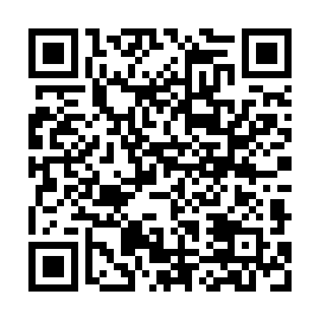
Prayer times for Nossa Senhora do Cabo, Portugal
Mon 1 Apr 2024 - Tue 30 Apr 2024
High Latitude Method: Angle Based Rule
Prayer Calculation Method: Muslim World League
Asar Calculation Method: Hanafi

Date | Day | Fajr | Sunrise | Dhuhr | Asr | Maghrib | Isha
1 | Mon | 5:51 | 7:21 | 1:41 | 6:11 | 8:01 | 9:26
2 | Tue | 5:49 | 7:20 | 1:40 | 6:11 | 8:01 | 9:27
3 | Wed | 5:47 | 7:18 | 1:40 | 6:12 | 8:02 | 9:28
4 | Thu | 5:45 | 7:17 | 1:40 | 6:12 | 8:03 | 9:29
5 | Fri | 5:44 | 7:15 | 1:39 | 6:13 | 8:04 | 9:30
6 | Sat | 5:42 | 7:14 | 1:39 | 6:14 | 8:05 | 9:31
7 | Sun | 5:40 | 7:12 | 1:39 | 6:14 | 8:06 | 9:33
8 | Mon | 5:38 | 7:11 | 1:39 | 6:15 | 8:07 | 9:34
9 | Tue | 5:37 | 7:09 | 1:38 | 6:15 | 8:08 | 9:35
10 | Wed | 5:35 | 7:08 | 1:38 | 6:16 | 8:09 | 9:36
11 | Thu | 5:33 | 7:06 | 1:38 | 6:16 | 8:10 | 9:37
12 | Fri | 5:31 | 7:05 | 1:38 | 6:17 | 8:11 | 9:39
13 | Sat | 5:30 | 7:03 | 1:37 | 6:18 | 8:12 | 9:40
14 | Sun | 5:28 | 7:02 | 1:37 | 6:18 | 8:13 | 9:41
15 | Mon | 5:26 | 7:00 | 1:37 | 6:19 | 8:14 | 9:42
16 | Tue | 5:24 | 6:59 | 1:37 | 6:19 | 8:15 | 9:44
17 | Wed | 5:23 | 6:58 | 1:36 | 6:20 | 8:16 | 9:45
18 | Thu | 5:21 | 6:56 | 1:36 | 6:20 | 8:17 | 9:46
19 | Fri | 5:19 | 6:55 | 1:36 | 6:21 | 8:18 | 9:47
20 | Sat | 5:18 | 6:53 | 1:36 | 6:21 | 8:18 | 9:49
21 | Sun | 5:16 | 6:52 | 1:35 | 6:22 | 8:19 | 9:50
22 | Mon | 5:14 | 6:51 | 1:35 | 6:22 | 8:20 | 9:51
23 | Tue | 5:12 | 6:49 | 1:35 | 6:23 | 8:21 | 9:52
24 | Wed | 5:11 | 6:48 | 1:35 | 6:24 | 8:22 | 9:54
25 | Thu | 5:09 | 6:47 | 1:35 | 6:24 | 8:23 | 9:55
26 | Fri | 5:07 | 6:46 | 1:35 | 6:25 | 8:24 | 9:56
27 | Sat | 5:06 | 6:44 | 1:34 | 6:25 | 8:25 | 9:58
28 | Sun | 5:04 | 6:43 | 1:34 | 6:26 | 8:26 | 9:59
29 | Mon | 5:03 | 6:42 | 1:34 | 6:26 | 8:27 | 10:00
30 | Tue | 5:01 | 6:41 | 1:34 | 6:27 | 8:28 | 10:02
Prayer times provided by https://www.salahtimes.com

