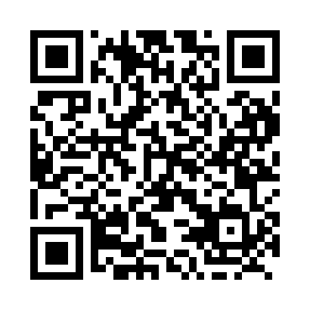
Prayer times for Grand Bank, Newfoundland and Labrador, Canada
Wed 1 May 2024 - Fri 31 May 2024
High Latitude Method: Angle Based Rule
Prayer Calculation Method: Islamic Society of North America
Asar Calculation Method: Hanafi

Date | Day | Fajr | Sunrise | Dhuhr | Asr | Maghrib | Isha
1 | Wed | 4:16 | 5:56 | 1:10 | 6:13 | 8:24 | 10:05
2 | Thu | 4:14 | 5:55 | 1:10 | 6:13 | 8:26 | 10:07
3 | Fri | 4:12 | 5:53 | 1:10 | 6:14 | 8:27 | 10:09
4 | Sat | 4:10 | 5:52 | 1:10 | 6:15 | 8:28 | 10:11
5 | Sun | 4:08 | 5:50 | 1:10 | 6:16 | 8:30 | 10:13
6 | Mon | 4:05 | 5:49 | 1:10 | 6:17 | 8:31 | 10:15
7 | Tue | 4:03 | 5:47 | 1:10 | 6:17 | 8:32 | 10:17
8 | Wed | 4:01 | 5:46 | 1:09 | 6:18 | 8:34 | 10:19
9 | Thu | 3:59 | 5:44 | 1:09 | 6:19 | 8:35 | 10:21
10 | Fri | 3:57 | 5:43 | 1:09 | 6:20 | 8:36 | 10:23
11 | Sat | 3:55 | 5:42 | 1:09 | 6:21 | 8:38 | 10:25
12 | Sun | 3:53 | 5:40 | 1:09 | 6:21 | 8:39 | 10:27
13 | Mon | 3:51 | 5:39 | 1:09 | 6:22 | 8:40 | 10:29
14 | Tue | 3:49 | 5:38 | 1:09 | 6:23 | 8:41 | 10:31
15 | Wed | 3:47 | 5:37 | 1:09 | 6:24 | 8:43 | 10:33
16 | Thu | 3:45 | 5:36 | 1:09 | 6:24 | 8:44 | 10:35
17 | Fri | 3:43 | 5:34 | 1:09 | 6:25 | 8:45 | 10:37
18 | Sat | 3:41 | 5:33 | 1:09 | 6:26 | 8:46 | 10:39
19 | Sun | 3:39 | 5:32 | 1:10 | 6:26 | 8:48 | 10:41
20 | Mon | 3:38 | 5:31 | 1:10 | 6:27 | 8:49 | 10:43
21 | Tue | 3:36 | 5:30 | 1:10 | 6:28 | 8:50 | 10:45
22 | Wed | 3:34 | 5:29 | 1:10 | 6:28 | 8:51 | 10:46
23 | Thu | 3:32 | 5:28 | 1:10 | 6:29 | 8:52 | 10:48
24 | Fri | 3:31 | 5:27 | 1:10 | 6:30 | 8:53 | 10:50
25 | Sat | 3:29 | 5:26 | 1:10 | 6:30 | 8:54 | 10:52
26 | Sun | 3:27 | 5:25 | 1:10 | 6:31 | 8:55 | 10:54
27 | Mon | 3:26 | 5:25 | 1:10 | 6:32 | 8:56 | 10:56
28 | Tue | 3:24 | 5:24 | 1:10 | 6:32 | 8:57 | 10:57
29 | Wed | 3:23 | 5:23 | 1:11 | 6:33 | 8:58 | 10:59
30 | Thu | 3:22 | 5:22 | 1:11 | 6:34 | 8:59 | 11:01
31 | Fri | 3:20 | 5:22 | 1:11 | 6:34 | 9:00 | 11:02
Prayer times provided by https://www.salahtimes.com

