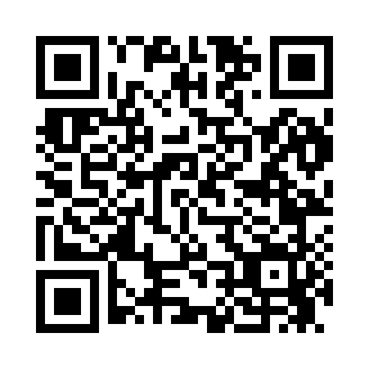
Prayer times for Delmues, Nevada, USA
Mon 1 Jul 2024 - Wed 31 Jul 2024
High Latitude Method: Angle Based Rule
Prayer Calculation Method: Islamic Society of North America
Asar Calculation Method: Shafi

Date | Day | Fajr | Sunrise | Dhuhr | Asr | Maghrib | Isha
1 | Mon | 3:48 | 5:19 | 12:41 | 4:35 | 8:03 | 9:35
2 | Tue | 3:48 | 5:20 | 12:42 | 4:35 | 8:03 | 9:34
3 | Wed | 3:49 | 5:20 | 12:42 | 4:35 | 8:03 | 9:34
4 | Thu | 3:50 | 5:21 | 12:42 | 4:36 | 8:03 | 9:34
5 | Fri | 3:50 | 5:21 | 12:42 | 4:36 | 8:03 | 9:33
6 | Sat | 3:51 | 5:22 | 12:42 | 4:36 | 8:02 | 9:33
7 | Sun | 3:52 | 5:22 | 12:42 | 4:36 | 8:02 | 9:32
8 | Mon | 3:53 | 5:23 | 12:43 | 4:36 | 8:02 | 9:32
9 | Tue | 3:54 | 5:24 | 12:43 | 4:36 | 8:01 | 9:31
10 | Wed | 3:54 | 5:24 | 12:43 | 4:36 | 8:01 | 9:31
11 | Thu | 3:55 | 5:25 | 12:43 | 4:36 | 8:01 | 9:30
12 | Fri | 3:56 | 5:26 | 12:43 | 4:36 | 8:00 | 9:29
13 | Sat | 3:57 | 5:26 | 12:43 | 4:36 | 8:00 | 9:29
14 | Sun | 3:58 | 5:27 | 12:43 | 4:36 | 7:59 | 9:28
15 | Mon | 3:59 | 5:28 | 12:43 | 4:36 | 7:59 | 9:27
16 | Tue | 4:00 | 5:28 | 12:43 | 4:36 | 7:58 | 9:26
17 | Wed | 4:01 | 5:29 | 12:44 | 4:36 | 7:58 | 9:25
18 | Thu | 4:02 | 5:30 | 12:44 | 4:36 | 7:57 | 9:24
19 | Fri | 4:03 | 5:31 | 12:44 | 4:36 | 7:56 | 9:24
20 | Sat | 4:04 | 5:31 | 12:44 | 4:36 | 7:56 | 9:23
21 | Sun | 4:05 | 5:32 | 12:44 | 4:36 | 7:55 | 9:22
22 | Mon | 4:06 | 5:33 | 12:44 | 4:36 | 7:54 | 9:21
23 | Tue | 4:08 | 5:34 | 12:44 | 4:36 | 7:53 | 9:19
24 | Wed | 4:09 | 5:35 | 12:44 | 4:35 | 7:53 | 9:18
25 | Thu | 4:10 | 5:35 | 12:44 | 4:35 | 7:52 | 9:17
26 | Fri | 4:11 | 5:36 | 12:44 | 4:35 | 7:51 | 9:16
27 | Sat | 4:12 | 5:37 | 12:44 | 4:35 | 7:50 | 9:15
28 | Sun | 4:13 | 5:38 | 12:44 | 4:35 | 7:49 | 9:14
29 | Mon | 4:14 | 5:39 | 12:44 | 4:35 | 7:48 | 9:12
30 | Tue | 4:15 | 5:40 | 12:44 | 4:34 | 7:47 | 9:11
31 | Wed | 4:17 | 5:40 | 12:44 | 4:34 | 7:46 | 9:10
Prayer times provided by https://www.salahtimes.com

