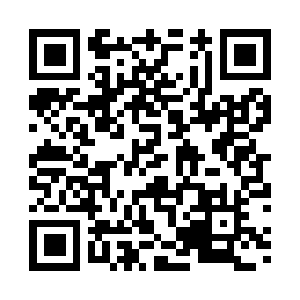
Prayer times for Lommoye, France
Mon 1 Apr 2024 - Tue 30 Apr 2024
High Latitude Method: Angle Based Rule
Prayer Calculation Method: Islamic Organisations Union of France
Asar Calculation Method: Shafi

Date | Day | Fajr | Sunrise | Dhuhr | Asr | Maghrib | Isha
1 | Mon | 6:20 | 7:31 | 1:58 | 5:32 | 8:26 | 9:36
2 | Tue | 6:18 | 7:29 | 1:57 | 5:33 | 8:27 | 9:38
3 | Wed | 6:16 | 7:27 | 1:57 | 5:33 | 8:29 | 9:40
4 | Thu | 6:13 | 7:24 | 1:57 | 5:34 | 8:30 | 9:41
5 | Fri | 6:11 | 7:22 | 1:57 | 5:35 | 8:32 | 9:43
6 | Sat | 6:09 | 7:20 | 1:56 | 5:35 | 8:33 | 9:45
7 | Sun | 6:06 | 7:18 | 1:56 | 5:36 | 8:35 | 9:47
8 | Mon | 6:04 | 7:16 | 1:56 | 5:37 | 8:36 | 9:48
9 | Tue | 6:02 | 7:14 | 1:55 | 5:38 | 8:38 | 9:50
10 | Wed | 5:59 | 7:12 | 1:55 | 5:38 | 8:39 | 9:52
11 | Thu | 5:57 | 7:10 | 1:55 | 5:39 | 8:41 | 9:54
12 | Fri | 5:55 | 7:08 | 1:55 | 5:40 | 8:42 | 9:56
13 | Sat | 5:52 | 7:06 | 1:54 | 5:40 | 8:44 | 9:57
14 | Sun | 5:50 | 7:04 | 1:54 | 5:41 | 8:45 | 9:59
15 | Mon | 5:48 | 7:02 | 1:54 | 5:42 | 8:47 | 10:01
16 | Tue | 5:45 | 7:00 | 1:54 | 5:42 | 8:48 | 10:03
17 | Wed | 5:43 | 6:58 | 1:53 | 5:43 | 8:50 | 10:05
18 | Thu | 5:41 | 6:56 | 1:53 | 5:44 | 8:51 | 10:07
19 | Fri | 5:39 | 6:54 | 1:53 | 5:44 | 8:53 | 10:09
20 | Sat | 5:36 | 6:52 | 1:53 | 5:45 | 8:54 | 10:10
21 | Sun | 5:34 | 6:50 | 1:53 | 5:46 | 8:56 | 10:12
22 | Mon | 5:32 | 6:49 | 1:52 | 5:46 | 8:57 | 10:14
23 | Tue | 5:29 | 6:47 | 1:52 | 5:47 | 8:59 | 10:16
24 | Wed | 5:27 | 6:45 | 1:52 | 5:47 | 9:00 | 10:18
25 | Thu | 5:25 | 6:43 | 1:52 | 5:48 | 9:01 | 10:20
26 | Fri | 5:23 | 6:41 | 1:52 | 5:49 | 9:03 | 10:22
27 | Sat | 5:20 | 6:39 | 1:52 | 5:49 | 9:04 | 10:24
28 | Sun | 5:18 | 6:38 | 1:51 | 5:50 | 9:06 | 10:26
29 | Mon | 5:16 | 6:36 | 1:51 | 5:50 | 9:07 | 10:28
30 | Tue | 5:14 | 6:34 | 1:51 | 5:51 | 9:09 | 10:30
Prayer times provided by https://www.salahtimes.com

