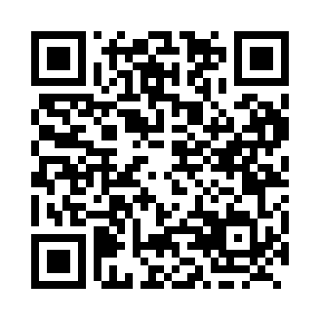
Prayer times for Campbell, Alberta, Canada
Wed 1 May 2024 - Fri 31 May 2024
High Latitude Method: Angle Based Rule
Prayer Calculation Method: Islamic Society of North America
Asar Calculation Method: Hanafi

Date | Day | Fajr | Sunrise | Dhuhr | Asr | Maghrib | Isha
1 | Wed | 3:49 | 5:58 | 1:31 | 6:41 | 9:06 | 11:15
2 | Thu | 3:46 | 5:56 | 1:31 | 6:42 | 9:08 | 11:19
3 | Fri | 3:43 | 5:54 | 1:31 | 6:44 | 9:10 | 11:21
4 | Sat | 3:42 | 5:52 | 1:31 | 6:45 | 9:11 | 11:21
5 | Sun | 3:41 | 5:50 | 1:31 | 6:46 | 9:13 | 11:22
6 | Mon | 3:40 | 5:48 | 1:31 | 6:47 | 9:15 | 11:23
7 | Tue | 3:39 | 5:46 | 1:31 | 6:48 | 9:17 | 11:24
8 | Wed | 3:38 | 5:44 | 1:31 | 6:49 | 9:18 | 11:25
9 | Thu | 3:37 | 5:42 | 1:31 | 6:50 | 9:20 | 11:26
10 | Fri | 3:36 | 5:40 | 1:31 | 6:51 | 9:22 | 11:27
11 | Sat | 3:35 | 5:39 | 1:31 | 6:52 | 9:24 | 11:27
12 | Sun | 3:34 | 5:37 | 1:31 | 6:53 | 9:25 | 11:28
13 | Mon | 3:33 | 5:35 | 1:31 | 6:54 | 9:27 | 11:29
14 | Tue | 3:32 | 5:33 | 1:31 | 6:55 | 9:29 | 11:30
15 | Wed | 3:31 | 5:32 | 1:31 | 6:56 | 9:30 | 11:31
16 | Thu | 3:31 | 5:30 | 1:31 | 6:57 | 9:32 | 11:32
17 | Fri | 3:30 | 5:29 | 1:31 | 6:58 | 9:34 | 11:32
18 | Sat | 3:29 | 5:27 | 1:31 | 6:59 | 9:35 | 11:33
19 | Sun | 3:28 | 5:26 | 1:31 | 7:00 | 9:37 | 11:34
20 | Mon | 3:28 | 5:24 | 1:31 | 7:00 | 9:38 | 11:35
21 | Tue | 3:27 | 5:23 | 1:31 | 7:01 | 9:40 | 11:36
22 | Wed | 3:26 | 5:21 | 1:31 | 7:02 | 9:41 | 11:36
23 | Thu | 3:26 | 5:20 | 1:31 | 7:03 | 9:43 | 11:37
24 | Fri | 3:25 | 5:19 | 1:31 | 7:04 | 9:44 | 11:38
25 | Sat | 3:25 | 5:18 | 1:31 | 7:05 | 9:46 | 11:39
26 | Sun | 3:24 | 5:16 | 1:31 | 7:06 | 9:47 | 11:39
27 | Mon | 3:24 | 5:15 | 1:32 | 7:06 | 9:48 | 11:40
28 | Tue | 3:23 | 5:14 | 1:32 | 7:07 | 9:50 | 11:41
29 | Wed | 3:23 | 5:13 | 1:32 | 7:08 | 9:51 | 11:42
30 | Thu | 3:22 | 5:12 | 1:32 | 7:09 | 9:52 | 11:42
31 | Fri | 3:22 | 5:11 | 1:32 | 7:09 | 9:53 | 11:43
Prayer times provided by https://www.salahtimes.com

