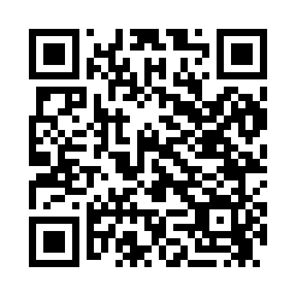
Prayer times for Balboa Island, California, USA
Mon 1 Jul 2024 - Wed 31 Jul 2024
High Latitude Method: Angle Based Rule
Prayer Calculation Method: Islamic Society of North America
Asar Calculation Method: Shafi

Date | Day | Fajr | Sunrise | Dhuhr | Asr | Maghrib | Isha
1 | Mon | 4:22 | 5:45 | 12:56 | 4:40 | 8:06 | 9:29
2 | Tue | 4:23 | 5:46 | 12:56 | 4:40 | 8:06 | 9:29
3 | Wed | 4:23 | 5:46 | 12:56 | 4:40 | 8:06 | 9:28
4 | Thu | 4:24 | 5:47 | 12:56 | 4:40 | 8:05 | 9:28
5 | Fri | 4:25 | 5:47 | 12:56 | 4:41 | 8:05 | 9:28
6 | Sat | 4:25 | 5:48 | 12:57 | 4:41 | 8:05 | 9:28
7 | Sun | 4:26 | 5:48 | 12:57 | 4:41 | 8:05 | 9:27
8 | Mon | 4:27 | 5:49 | 12:57 | 4:41 | 8:05 | 9:27
9 | Tue | 4:27 | 5:49 | 12:57 | 4:41 | 8:04 | 9:26
10 | Wed | 4:28 | 5:50 | 12:57 | 4:41 | 8:04 | 9:26
11 | Thu | 4:29 | 5:50 | 12:57 | 4:41 | 8:04 | 9:25
12 | Fri | 4:30 | 5:51 | 12:57 | 4:42 | 8:03 | 9:25
13 | Sat | 4:30 | 5:52 | 12:57 | 4:42 | 8:03 | 9:24
14 | Sun | 4:31 | 5:52 | 12:58 | 4:42 | 8:03 | 9:24
15 | Mon | 4:32 | 5:53 | 12:58 | 4:42 | 8:02 | 9:23
16 | Tue | 4:33 | 5:54 | 12:58 | 4:42 | 8:02 | 9:22
17 | Wed | 4:34 | 5:54 | 12:58 | 4:42 | 8:01 | 9:22
18 | Thu | 4:34 | 5:55 | 12:58 | 4:42 | 8:01 | 9:21
19 | Fri | 4:35 | 5:55 | 12:58 | 4:42 | 8:00 | 9:20
20 | Sat | 4:36 | 5:56 | 12:58 | 4:42 | 8:00 | 9:19
21 | Sun | 4:37 | 5:57 | 12:58 | 4:42 | 7:59 | 9:19
22 | Mon | 4:38 | 5:57 | 12:58 | 4:42 | 7:58 | 9:18
23 | Tue | 4:39 | 5:58 | 12:58 | 4:42 | 7:58 | 9:17
24 | Wed | 4:40 | 5:59 | 12:58 | 4:42 | 7:57 | 9:16
25 | Thu | 4:41 | 5:59 | 12:58 | 4:42 | 7:56 | 9:15
26 | Fri | 4:42 | 6:00 | 12:58 | 4:42 | 7:56 | 9:14
27 | Sat | 4:43 | 6:01 | 12:58 | 4:42 | 7:55 | 9:13
28 | Sun | 4:43 | 6:02 | 12:58 | 4:42 | 7:54 | 9:12
29 | Mon | 4:44 | 6:02 | 12:58 | 4:42 | 7:53 | 9:11
30 | Tue | 4:45 | 6:03 | 12:58 | 4:41 | 7:53 | 9:10
31 | Wed | 4:46 | 6:04 | 12:58 | 4:41 | 7:52 | 9:09
Prayer times provided by https://www.salahtimes.com

