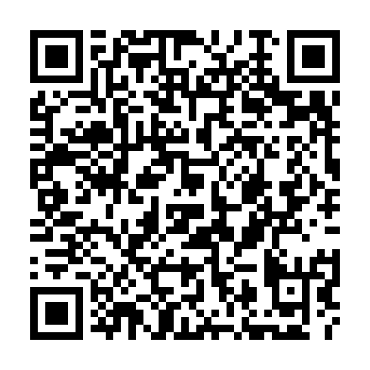
Prayer times for Utatnun Kaiahtet Uhakatshuku, Quebec, Canada
Wed 1 May 2024 - Fri 31 May 2024
High Latitude Method: Angle Based Rule
Prayer Calculation Method: Islamic Society of North America
Asar Calculation Method: Hanafi

Date | Day | Fajr | Sunrise | Dhuhr | Asr | Maghrib | Isha
1 | Wed | 2:42 | 4:34 | 11:56 | 5:03 | 7:20 | 9:12
2 | Thu | 2:39 | 4:32 | 11:56 | 5:04 | 7:22 | 9:15
3 | Fri | 2:37 | 4:30 | 11:56 | 5:04 | 7:23 | 9:17
4 | Sat | 2:34 | 4:28 | 11:56 | 5:05 | 7:25 | 9:20
5 | Sun | 2:31 | 4:27 | 11:56 | 5:06 | 7:26 | 9:22
6 | Mon | 2:28 | 4:25 | 11:56 | 5:07 | 7:28 | 9:25
7 | Tue | 2:26 | 4:23 | 11:56 | 5:08 | 7:29 | 9:27
8 | Wed | 2:23 | 4:22 | 11:56 | 5:09 | 7:31 | 9:30
9 | Thu | 2:21 | 4:20 | 11:56 | 5:10 | 7:32 | 9:32
10 | Fri | 2:18 | 4:18 | 11:56 | 5:11 | 7:34 | 9:35
11 | Sat | 2:15 | 4:17 | 11:56 | 5:12 | 7:35 | 9:38
12 | Sun | 2:13 | 4:15 | 11:56 | 5:13 | 7:37 | 9:40
13 | Mon | 2:10 | 4:14 | 11:56 | 5:13 | 7:38 | 9:43
14 | Tue | 2:07 | 4:13 | 11:56 | 5:14 | 7:40 | 9:45
15 | Wed | 2:05 | 4:11 | 11:56 | 5:15 | 7:41 | 9:48
16 | Thu | 2:03 | 4:10 | 11:56 | 5:16 | 7:42 | 9:49
17 | Fri | 2:02 | 4:08 | 11:56 | 5:17 | 7:44 | 9:50
18 | Sat | 2:02 | 4:07 | 11:56 | 5:18 | 7:45 | 9:51
19 | Sun | 2:01 | 4:06 | 11:56 | 5:18 | 7:47 | 9:51
20 | Mon | 2:00 | 4:05 | 11:56 | 5:19 | 7:48 | 9:52
21 | Tue | 2:00 | 4:03 | 11:56 | 5:20 | 7:49 | 9:53
22 | Wed | 1:59 | 4:02 | 11:56 | 5:21 | 7:51 | 9:53
23 | Thu | 1:59 | 4:01 | 11:56 | 5:22 | 7:52 | 9:54
24 | Fri | 1:58 | 4:00 | 11:56 | 5:22 | 7:53 | 9:55
25 | Sat | 1:58 | 3:59 | 11:56 | 5:23 | 7:54 | 9:55
26 | Sun | 1:57 | 3:58 | 11:56 | 5:24 | 7:55 | 9:56
27 | Mon | 1:57 | 3:57 | 11:57 | 5:24 | 7:57 | 9:57
28 | Tue | 1:57 | 3:56 | 11:57 | 5:25 | 7:58 | 9:57
29 | Wed | 1:56 | 3:55 | 11:57 | 5:26 | 7:59 | 9:58
30 | Thu | 1:56 | 3:54 | 11:57 | 5:26 | 8:00 | 9:59
31 | Fri | 1:56 | 3:54 | 11:57 | 5:27 | 8:01 | 9:59
Prayer times provided by https://www.salahtimes.com

