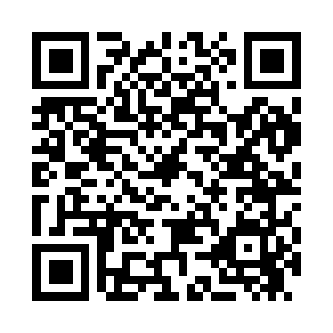
Prayer times for Chesuncook, Maine, USA
Mon 1 Jul 2024 - Wed 31 Jul 2024
High Latitude Method: Angle Based Rule
Prayer Calculation Method: Islamic Society of North America
Asar Calculation Method: Shafi

Date | Day | Fajr | Sunrise | Dhuhr | Asr | Maghrib | Isha
1 | Mon | 2:50 | 4:51 | 12:42 | 4:53 | 8:32 | 10:33
2 | Tue | 2:51 | 4:52 | 12:42 | 4:53 | 8:32 | 10:32
3 | Wed | 2:52 | 4:52 | 12:42 | 4:53 | 8:32 | 10:32
4 | Thu | 2:53 | 4:53 | 12:42 | 4:53 | 8:31 | 10:31
5 | Fri | 2:54 | 4:54 | 12:42 | 4:53 | 8:31 | 10:30
6 | Sat | 2:56 | 4:54 | 12:43 | 4:53 | 8:31 | 10:29
7 | Sun | 2:57 | 4:55 | 12:43 | 4:53 | 8:30 | 10:28
8 | Mon | 2:58 | 4:56 | 12:43 | 4:53 | 8:30 | 10:27
9 | Tue | 2:59 | 4:57 | 12:43 | 4:53 | 8:29 | 10:26
10 | Wed | 3:01 | 4:57 | 12:43 | 4:53 | 8:28 | 10:25
11 | Thu | 3:02 | 4:58 | 12:43 | 4:52 | 8:28 | 10:24
12 | Fri | 3:04 | 4:59 | 12:43 | 4:52 | 8:27 | 10:22
13 | Sat | 3:05 | 5:00 | 12:44 | 4:52 | 8:26 | 10:21
14 | Sun | 3:07 | 5:01 | 12:44 | 4:52 | 8:26 | 10:20
15 | Mon | 3:08 | 5:02 | 12:44 | 4:52 | 8:25 | 10:18
16 | Tue | 3:10 | 5:03 | 12:44 | 4:52 | 8:24 | 10:17
17 | Wed | 3:11 | 5:04 | 12:44 | 4:52 | 8:23 | 10:15
18 | Thu | 3:13 | 5:05 | 12:44 | 4:51 | 8:22 | 10:14
19 | Fri | 3:15 | 5:06 | 12:44 | 4:51 | 8:22 | 10:12
20 | Sat | 3:17 | 5:07 | 12:44 | 4:51 | 8:21 | 10:11
21 | Sun | 3:18 | 5:08 | 12:44 | 4:51 | 8:20 | 10:09
22 | Mon | 3:20 | 5:09 | 12:44 | 4:50 | 8:19 | 10:07
23 | Tue | 3:22 | 5:10 | 12:44 | 4:50 | 8:18 | 10:06
24 | Wed | 3:23 | 5:11 | 12:44 | 4:50 | 8:16 | 10:04
25 | Thu | 3:25 | 5:13 | 12:44 | 4:49 | 8:15 | 10:02
26 | Fri | 3:27 | 5:14 | 12:44 | 4:49 | 8:14 | 10:00
27 | Sat | 3:29 | 5:15 | 12:44 | 4:48 | 8:13 | 9:59
28 | Sun | 3:31 | 5:16 | 12:44 | 4:48 | 8:12 | 9:57
29 | Mon | 3:32 | 5:17 | 12:44 | 4:47 | 8:11 | 9:55
30 | Tue | 3:34 | 5:18 | 12:44 | 4:47 | 8:09 | 9:53
31 | Wed | 3:36 | 5:19 | 12:44 | 4:46 | 8:08 | 9:51
Prayer times provided by https://www.salahtimes.com

