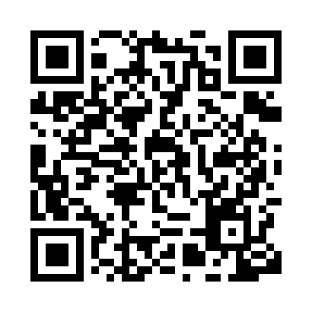
Prayer times for A Barra, Spain
Sat 1 Jun 2024 - Sun 30 Jun 2024
High Latitude Method: Angle Based Rule
Prayer Calculation Method: Muslim World League
Asar Calculation Method: Hanafi

Date | Day | Fajr | Sunrise | Dhuhr | Asr | Maghrib | Isha
1 | Sat | 4:47 | 6:57 | 2:29 | 7:44 | 10:02 | 12:02
2 | Sun | 4:46 | 6:56 | 2:29 | 7:44 | 10:03 | 12:03
3 | Mon | 4:46 | 6:56 | 2:30 | 7:45 | 10:04 | 12:04
4 | Tue | 4:45 | 6:55 | 2:30 | 7:45 | 10:04 | 12:06
5 | Wed | 4:44 | 6:55 | 2:30 | 7:46 | 10:05 | 12:07
6 | Thu | 4:43 | 6:55 | 2:30 | 7:46 | 10:06 | 12:08
7 | Fri | 4:42 | 6:54 | 2:30 | 7:47 | 10:06 | 12:09
8 | Sat | 4:42 | 6:54 | 2:30 | 7:47 | 10:07 | 12:10
9 | Sun | 4:41 | 6:54 | 2:31 | 7:47 | 10:07 | 12:11
10 | Mon | 4:41 | 6:54 | 2:31 | 7:48 | 10:08 | 12:11
11 | Tue | 4:40 | 6:54 | 2:31 | 7:48 | 10:09 | 12:12
12 | Wed | 4:40 | 6:54 | 2:31 | 7:48 | 10:09 | 12:13
13 | Thu | 4:39 | 6:54 | 2:31 | 7:49 | 10:09 | 12:14
14 | Fri | 4:39 | 6:54 | 2:32 | 7:49 | 10:10 | 12:14
15 | Sat | 4:39 | 6:54 | 2:32 | 7:49 | 10:10 | 12:15
16 | Sun | 4:39 | 6:54 | 2:32 | 7:50 | 10:11 | 12:15
17 | Mon | 4:39 | 6:54 | 2:32 | 7:50 | 10:11 | 12:16
18 | Tue | 4:39 | 6:54 | 2:33 | 7:50 | 10:11 | 12:16
19 | Wed | 4:39 | 6:54 | 2:33 | 7:51 | 10:12 | 12:16
20 | Thu | 4:39 | 6:54 | 2:33 | 7:51 | 10:12 | 12:17
21 | Fri | 4:39 | 6:54 | 2:33 | 7:51 | 10:12 | 12:17
22 | Sat | 4:39 | 6:55 | 2:33 | 7:51 | 10:12 | 12:17
23 | Sun | 4:40 | 6:55 | 2:34 | 7:51 | 10:12 | 12:17
24 | Mon | 4:40 | 6:55 | 2:34 | 7:52 | 10:12 | 12:17
25 | Tue | 4:41 | 6:56 | 2:34 | 7:52 | 10:12 | 12:17
26 | Wed | 4:41 | 6:56 | 2:34 | 7:52 | 10:13 | 12:17
27 | Thu | 4:42 | 6:56 | 2:34 | 7:52 | 10:13 | 12:17
28 | Fri | 4:42 | 6:57 | 2:35 | 7:52 | 10:12 | 12:16
29 | Sat | 4:43 | 6:57 | 2:35 | 7:52 | 10:12 | 12:16
30 | Sun | 4:44 | 6:58 | 2:35 | 7:52 | 10:12 | 12:16
Prayer times provided by https://www.salahtimes.com

