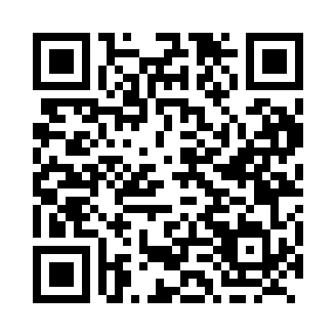
Prayer times for Ivujivik, Quebec, Canada
Mon 1 Jul 2024 - Wed 31 Jul 2024
High Latitude Method: Angle Based Rule
Prayer Calculation Method: Islamic Society of North America
Asar Calculation Method: Hanafi

Date | Day | Fajr | Sunrise | Dhuhr | Asr | Maghrib | Isha
1 | Mon | 2:19 | 3:23 | 1:16 | 7:23 | 11:07 | 12:11
2 | Tue | 2:20 | 3:25 | 1:16 | 7:22 | 11:06 | 12:11
3 | Wed | 2:21 | 3:26 | 1:16 | 7:22 | 11:05 | 12:10
4 | Thu | 2:22 | 3:28 | 1:16 | 7:22 | 11:04 | 12:10
5 | Fri | 2:23 | 3:30 | 1:16 | 7:21 | 11:02 | 12:09
6 | Sat | 2:24 | 3:32 | 1:17 | 7:21 | 11:01 | 12:08
7 | Sun | 2:25 | 3:34 | 1:17 | 7:20 | 10:59 | 12:08
8 | Mon | 2:26 | 3:36 | 1:17 | 7:20 | 10:57 | 12:07
9 | Tue | 2:27 | 3:38 | 1:17 | 7:19 | 10:55 | 12:06
10 | Wed | 2:28 | 3:40 | 1:17 | 7:18 | 10:54 | 12:05
11 | Thu | 2:29 | 3:42 | 1:17 | 7:18 | 10:52 | 12:04
12 | Fri | 2:31 | 3:44 | 1:17 | 7:17 | 10:50 | 12:03
13 | Sat | 2:32 | 3:47 | 1:18 | 7:16 | 10:47 | 12:02
14 | Sun | 2:33 | 3:49 | 1:18 | 7:15 | 10:45 | 12:01
15 | Mon | 2:34 | 3:51 | 1:18 | 7:14 | 10:43 | 12:00
16 | Tue | 2:35 | 3:54 | 1:18 | 7:14 | 10:41 | 11:59
17 | Wed | 2:37 | 3:56 | 1:18 | 7:13 | 10:38 | 11:58
18 | Thu | 2:38 | 3:59 | 1:18 | 7:12 | 10:36 | 11:57
19 | Fri | 2:39 | 4:01 | 1:18 | 7:11 | 10:34 | 11:56
20 | Sat | 2:41 | 4:04 | 1:18 | 7:09 | 10:31 | 11:54
21 | Sun | 2:42 | 4:06 | 1:18 | 7:08 | 10:29 | 11:53
22 | Mon | 2:43 | 4:09 | 1:18 | 7:07 | 10:26 | 11:52
23 | Tue | 2:45 | 4:12 | 1:18 | 7:06 | 10:23 | 11:50
24 | Wed | 2:46 | 4:14 | 1:18 | 7:05 | 10:21 | 11:49
25 | Thu | 2:47 | 4:17 | 1:18 | 7:03 | 10:18 | 11:48
26 | Fri | 2:49 | 4:20 | 1:18 | 7:02 | 10:15 | 11:46
27 | Sat | 2:50 | 4:23 | 1:18 | 7:01 | 10:12 | 11:45
28 | Sun | 2:51 | 4:25 | 1:18 | 6:59 | 10:10 | 11:44
29 | Mon | 2:53 | 4:28 | 1:18 | 6:58 | 10:07 | 11:42
30 | Tue | 2:54 | 4:31 | 1:18 | 6:56 | 10:04 | 11:41
31 | Wed | 2:55 | 4:34 | 1:18 | 6:55 | 10:01 | 11:39
Prayer times provided by https://www.salahtimes.com

