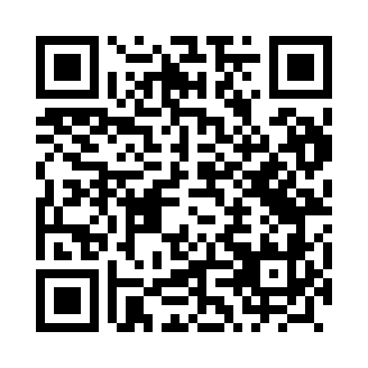
Prayer times for Sosnowik, Poland
Wed 1 May 2024 - Fri 31 May 2024
High Latitude Method: Angle Based Rule
Prayer Calculation Method: Muslim World League
Asar Calculation Method: Hanafi

Date | Day | Fajr | Sunrise | Dhuhr | Asr | Maghrib | Isha
1 | Wed | 2:10 | 4:51 | 12:23 | 5:32 | 7:55 | 10:26
2 | Thu | 2:09 | 4:49 | 12:22 | 5:33 | 7:57 | 10:28
3 | Fri | 2:09 | 4:47 | 12:22 | 5:34 | 7:59 | 10:28
4 | Sat | 2:08 | 4:45 | 12:22 | 5:35 | 8:00 | 10:29
5 | Sun | 2:07 | 4:43 | 12:22 | 5:36 | 8:02 | 10:30
6 | Mon | 2:06 | 4:41 | 12:22 | 5:37 | 8:04 | 10:30
7 | Tue | 2:05 | 4:39 | 12:22 | 5:38 | 8:06 | 10:31
8 | Wed | 2:05 | 4:38 | 12:22 | 5:39 | 8:07 | 10:32
9 | Thu | 2:04 | 4:36 | 12:22 | 5:40 | 8:09 | 10:33
10 | Fri | 2:03 | 4:34 | 12:22 | 5:41 | 8:11 | 10:33
11 | Sat | 2:02 | 4:32 | 12:22 | 5:42 | 8:12 | 10:34
12 | Sun | 2:02 | 4:31 | 12:22 | 5:43 | 8:14 | 10:35
13 | Mon | 2:01 | 4:29 | 12:22 | 5:44 | 8:16 | 10:35
14 | Tue | 2:00 | 4:27 | 12:22 | 5:45 | 8:17 | 10:36
15 | Wed | 2:00 | 4:26 | 12:22 | 5:46 | 8:19 | 10:37
16 | Thu | 1:59 | 4:24 | 12:22 | 5:47 | 8:21 | 10:38
17 | Fri | 1:58 | 4:23 | 12:22 | 5:48 | 8:22 | 10:38
18 | Sat | 1:58 | 4:21 | 12:22 | 5:49 | 8:24 | 10:39
19 | Sun | 1:57 | 4:20 | 12:22 | 5:50 | 8:25 | 10:40
20 | Mon | 1:57 | 4:18 | 12:22 | 5:51 | 8:27 | 10:40
21 | Tue | 1:56 | 4:17 | 12:22 | 5:51 | 8:28 | 10:41
22 | Wed | 1:56 | 4:15 | 12:22 | 5:52 | 8:30 | 10:42
23 | Thu | 1:55 | 4:14 | 12:22 | 5:53 | 8:31 | 10:42
24 | Fri | 1:55 | 4:13 | 12:22 | 5:54 | 8:33 | 10:43
25 | Sat | 1:54 | 4:12 | 12:23 | 5:55 | 8:34 | 10:44
26 | Sun | 1:54 | 4:10 | 12:23 | 5:56 | 8:35 | 10:44
27 | Mon | 1:54 | 4:09 | 12:23 | 5:56 | 8:37 | 10:45
28 | Tue | 1:53 | 4:08 | 12:23 | 5:57 | 8:38 | 10:46
29 | Wed | 1:53 | 4:07 | 12:23 | 5:58 | 8:39 | 10:46
30 | Thu | 1:53 | 4:06 | 12:23 | 5:59 | 8:41 | 10:47
31 | Fri | 1:52 | 4:05 | 12:23 | 5:59 | 8:42 | 10:47
Prayer times provided by https://www.salahtimes.com

