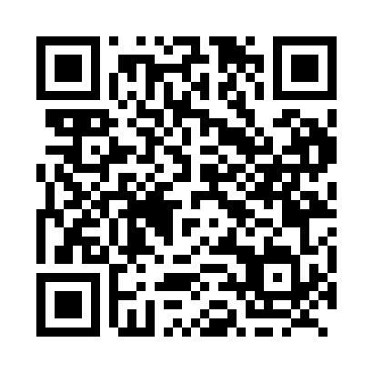
Prayer times for Flemming, New Brunswick, Canada
Mon 1 Jul 2024 - Wed 31 Jul 2024
High Latitude Method: Angle Based Rule
Prayer Calculation Method: Islamic Society of North America
Asar Calculation Method: Hanafi

Date | Day | Fajr | Sunrise | Dhuhr | Asr | Maghrib | Isha
1 | Mon | 3:38 | 5:40 | 1:35 | 7:02 | 9:31 | 11:33
2 | Tue | 3:38 | 5:40 | 1:36 | 7:02 | 9:31 | 11:33
3 | Wed | 3:38 | 5:41 | 1:36 | 7:02 | 9:31 | 11:33
4 | Thu | 3:39 | 5:42 | 1:36 | 7:02 | 9:30 | 11:33
5 | Fri | 3:39 | 5:42 | 1:36 | 7:02 | 9:30 | 11:33
6 | Sat | 3:40 | 5:43 | 1:36 | 7:02 | 9:29 | 11:33
7 | Sun | 3:40 | 5:44 | 1:37 | 7:01 | 9:29 | 11:33
8 | Mon | 3:41 | 5:45 | 1:37 | 7:01 | 9:28 | 11:32
9 | Tue | 3:41 | 5:46 | 1:37 | 7:01 | 9:28 | 11:31
10 | Wed | 3:43 | 5:46 | 1:37 | 7:01 | 9:27 | 11:30
11 | Thu | 3:45 | 5:47 | 1:37 | 7:00 | 9:26 | 11:29
12 | Fri | 3:46 | 5:48 | 1:37 | 7:00 | 9:26 | 11:27
13 | Sat | 3:48 | 5:49 | 1:37 | 7:00 | 9:25 | 11:26
14 | Sun | 3:50 | 5:50 | 1:37 | 6:59 | 9:24 | 11:24
15 | Mon | 3:51 | 5:51 | 1:38 | 6:59 | 9:23 | 11:23
16 | Tue | 3:53 | 5:52 | 1:38 | 6:59 | 9:23 | 11:21
17 | Wed | 3:55 | 5:53 | 1:38 | 6:58 | 9:22 | 11:20
18 | Thu | 3:57 | 5:54 | 1:38 | 6:58 | 9:21 | 11:18
19 | Fri | 3:59 | 5:55 | 1:38 | 6:57 | 9:20 | 11:16
20 | Sat | 4:00 | 5:56 | 1:38 | 6:57 | 9:19 | 11:14
21 | Sun | 4:02 | 5:58 | 1:38 | 6:56 | 9:18 | 11:13
22 | Mon | 4:04 | 5:59 | 1:38 | 6:55 | 9:17 | 11:11
23 | Tue | 4:06 | 6:00 | 1:38 | 6:55 | 9:16 | 11:09
24 | Wed | 4:08 | 6:01 | 1:38 | 6:54 | 9:14 | 11:07
25 | Thu | 4:10 | 6:02 | 1:38 | 6:54 | 9:13 | 11:05
26 | Fri | 4:12 | 6:03 | 1:38 | 6:53 | 9:12 | 11:03
27 | Sat | 4:14 | 6:05 | 1:38 | 6:52 | 9:11 | 11:01
28 | Sun | 4:16 | 6:06 | 1:38 | 6:51 | 9:10 | 10:59
29 | Mon | 4:18 | 6:07 | 1:38 | 6:51 | 9:08 | 10:57
30 | Tue | 4:20 | 6:08 | 1:38 | 6:50 | 9:07 | 10:55
31 | Wed | 4:22 | 6:09 | 1:38 | 6:49 | 9:06 | 10:53
Prayer times provided by https://www.salahtimes.com

