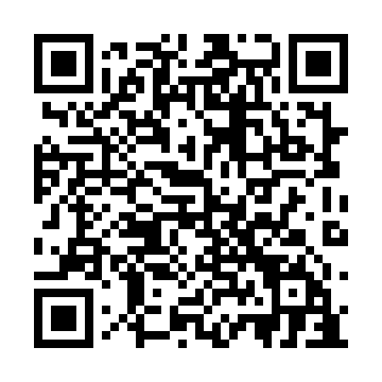
Prayer times for Sunset View Beach, Saskatchewan, Canada
Mon 1 Jul 2024 - Wed 31 Jul 2024
High Latitude Method: Angle Based Rule
Prayer Calculation Method: Islamic Society of North America
Asar Calculation Method: Hanafi

Date | Day | Fajr | Sunrise | Dhuhr | Asr | Maghrib | Isha
1 | Mon | 3:04 | 4:50 | 1:19 | 6:59 | 9:47 | 11:32
2 | Tue | 3:05 | 4:51 | 1:19 | 6:59 | 9:46 | 11:32
3 | Wed | 3:05 | 4:52 | 1:19 | 6:59 | 9:46 | 11:32
4 | Thu | 3:06 | 4:53 | 1:19 | 6:59 | 9:45 | 11:32
5 | Fri | 3:06 | 4:54 | 1:19 | 6:59 | 9:44 | 11:32
6 | Sat | 3:07 | 4:55 | 1:19 | 6:58 | 9:44 | 11:31
7 | Sun | 3:08 | 4:56 | 1:20 | 6:58 | 9:43 | 11:31
8 | Mon | 3:08 | 4:57 | 1:20 | 6:58 | 9:42 | 11:31
9 | Tue | 3:09 | 4:58 | 1:20 | 6:57 | 9:41 | 11:31
10 | Wed | 3:09 | 4:59 | 1:20 | 6:57 | 9:40 | 11:30
11 | Thu | 3:10 | 5:00 | 1:20 | 6:57 | 9:40 | 11:30
12 | Fri | 3:11 | 5:02 | 1:20 | 6:56 | 9:39 | 11:29
13 | Sat | 3:11 | 5:03 | 1:20 | 6:56 | 9:37 | 11:29
14 | Sun | 3:12 | 5:04 | 1:21 | 6:55 | 9:36 | 11:28
15 | Mon | 3:13 | 5:05 | 1:21 | 6:55 | 9:35 | 11:28
16 | Tue | 3:14 | 5:07 | 1:21 | 6:54 | 9:34 | 11:27
17 | Wed | 3:14 | 5:08 | 1:21 | 6:53 | 9:33 | 11:27
18 | Thu | 3:15 | 5:09 | 1:21 | 6:53 | 9:32 | 11:26
19 | Fri | 3:16 | 5:11 | 1:21 | 6:52 | 9:30 | 11:25
20 | Sat | 3:16 | 5:12 | 1:21 | 6:51 | 9:29 | 11:25
21 | Sun | 3:17 | 5:14 | 1:21 | 6:51 | 9:27 | 11:24
22 | Mon | 3:18 | 5:15 | 1:21 | 6:50 | 9:26 | 11:23
23 | Tue | 3:19 | 5:17 | 1:21 | 6:49 | 9:25 | 11:23
24 | Wed | 3:20 | 5:18 | 1:21 | 6:48 | 9:23 | 11:22
25 | Thu | 3:20 | 5:20 | 1:21 | 6:47 | 9:21 | 11:21
26 | Fri | 3:21 | 5:21 | 1:21 | 6:46 | 9:20 | 11:20
27 | Sat | 3:22 | 5:23 | 1:21 | 6:45 | 9:18 | 11:19
28 | Sun | 3:23 | 5:25 | 1:21 | 6:44 | 9:17 | 11:19
29 | Mon | 3:23 | 5:26 | 1:21 | 6:43 | 9:15 | 11:18
30 | Tue | 3:24 | 5:28 | 1:21 | 6:42 | 9:13 | 11:17
31 | Wed | 3:25 | 5:30 | 1:21 | 6:41 | 9:11 | 11:16
Prayer times provided by https://www.salahtimes.com

