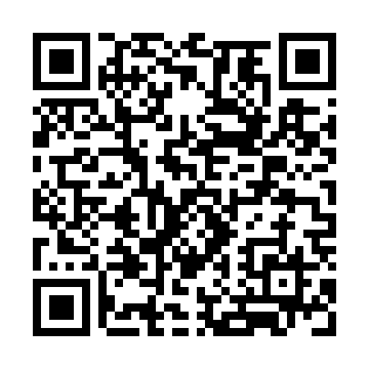
Prayer times for Arlington Station, California, USA
Sat 1 Jun 2024 - Sun 30 Jun 2024
High Latitude Method: Angle Based Rule
Prayer Calculation Method: Islamic Society of North America
Asar Calculation Method: Shafi

Date | Day | Fajr | Sunrise | Dhuhr | Asr | Maghrib | Isha
1 | Sat | 4:17 | 5:40 | 12:48 | 4:33 | 7:56 | 9:19
2 | Sun | 4:17 | 5:39 | 12:48 | 4:33 | 7:57 | 9:19
3 | Mon | 4:16 | 5:39 | 12:48 | 4:33 | 7:57 | 9:20
4 | Tue | 4:16 | 5:39 | 12:48 | 4:33 | 7:58 | 9:21
5 | Wed | 4:16 | 5:39 | 12:48 | 4:33 | 7:58 | 9:21
6 | Thu | 4:15 | 5:39 | 12:49 | 4:34 | 7:59 | 9:22
7 | Fri | 4:15 | 5:38 | 12:49 | 4:34 | 7:59 | 9:23
8 | Sat | 4:15 | 5:38 | 12:49 | 4:34 | 8:00 | 9:23
9 | Sun | 4:15 | 5:38 | 12:49 | 4:34 | 8:00 | 9:24
10 | Mon | 4:15 | 5:38 | 12:49 | 4:34 | 8:01 | 9:24
11 | Tue | 4:14 | 5:38 | 12:50 | 4:35 | 8:01 | 9:25
12 | Wed | 4:14 | 5:38 | 12:50 | 4:35 | 8:02 | 9:25
13 | Thu | 4:14 | 5:38 | 12:50 | 4:35 | 8:02 | 9:26
14 | Fri | 4:14 | 5:38 | 12:50 | 4:35 | 8:02 | 9:26
15 | Sat | 4:14 | 5:38 | 12:50 | 4:35 | 8:03 | 9:27
16 | Sun | 4:14 | 5:38 | 12:51 | 4:36 | 8:03 | 9:27
17 | Mon | 4:14 | 5:39 | 12:51 | 4:36 | 8:03 | 9:27
18 | Tue | 4:15 | 5:39 | 12:51 | 4:36 | 8:03 | 9:28
19 | Wed | 4:15 | 5:39 | 12:51 | 4:36 | 8:04 | 9:28
20 | Thu | 4:15 | 5:39 | 12:52 | 4:37 | 8:04 | 9:28
21 | Fri | 4:15 | 5:39 | 12:52 | 4:37 | 8:04 | 9:28
22 | Sat | 4:15 | 5:40 | 12:52 | 4:37 | 8:04 | 9:29
23 | Sun | 4:16 | 5:40 | 12:52 | 4:37 | 8:04 | 9:29
24 | Mon | 4:16 | 5:40 | 12:52 | 4:37 | 8:05 | 9:29
25 | Tue | 4:16 | 5:40 | 12:53 | 4:38 | 8:05 | 9:29
26 | Wed | 4:17 | 5:41 | 12:53 | 4:38 | 8:05 | 9:29
27 | Thu | 4:17 | 5:41 | 12:53 | 4:38 | 8:05 | 9:29
28 | Fri | 4:18 | 5:42 | 12:53 | 4:38 | 8:05 | 9:29
29 | Sat | 4:18 | 5:42 | 12:53 | 4:38 | 8:05 | 9:29
30 | Sun | 4:19 | 5:42 | 12:54 | 4:39 | 8:05 | 9:29
Prayer times provided by https://www.salahtimes.com

