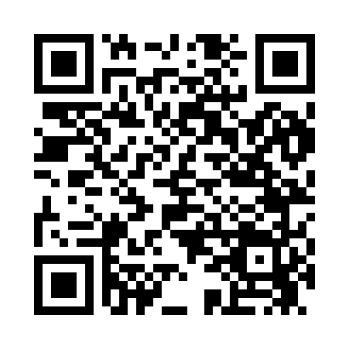
Prayer times for Barnstable, Massachusetts, USA
Wed 1 May 2024 - Fri 31 May 2024
High Latitude Method: Angle Based Rule
Prayer Calculation Method: Islamic Society of North America
Asar Calculation Method: Shafi

Date | Day | Fajr | Sunrise | Dhuhr | Asr | Maghrib | Isha
1 | Wed | 4:10 | 5:37 | 12:38 | 4:31 | 7:40 | 9:07
2 | Thu | 4:08 | 5:36 | 12:38 | 4:31 | 7:41 | 9:09
3 | Fri | 4:07 | 5:34 | 12:38 | 4:32 | 7:42 | 9:10
4 | Sat | 4:05 | 5:33 | 12:38 | 4:32 | 7:43 | 9:12
5 | Sun | 4:03 | 5:32 | 12:38 | 4:32 | 7:44 | 9:13
6 | Mon | 4:02 | 5:31 | 12:38 | 4:32 | 7:45 | 9:15
7 | Tue | 4:00 | 5:30 | 12:38 | 4:33 | 7:46 | 9:16
8 | Wed | 3:59 | 5:28 | 12:38 | 4:33 | 7:47 | 9:18
9 | Thu | 3:57 | 5:27 | 12:38 | 4:33 | 7:49 | 9:19
10 | Fri | 3:55 | 5:26 | 12:38 | 4:34 | 7:50 | 9:21
11 | Sat | 3:54 | 5:25 | 12:38 | 4:34 | 7:51 | 9:22
12 | Sun | 3:52 | 5:24 | 12:38 | 4:34 | 7:52 | 9:24
13 | Mon | 3:51 | 5:23 | 12:38 | 4:35 | 7:53 | 9:25
14 | Tue | 3:49 | 5:22 | 12:38 | 4:35 | 7:54 | 9:26
15 | Wed | 3:48 | 5:21 | 12:38 | 4:35 | 7:55 | 9:28
16 | Thu | 3:47 | 5:20 | 12:38 | 4:35 | 7:56 | 9:29
17 | Fri | 3:45 | 5:19 | 12:38 | 4:36 | 7:57 | 9:31
18 | Sat | 3:44 | 5:18 | 12:38 | 4:36 | 7:58 | 9:32
19 | Sun | 3:43 | 5:17 | 12:38 | 4:36 | 7:59 | 9:33
20 | Mon | 3:41 | 5:16 | 12:38 | 4:37 | 8:00 | 9:35
21 | Tue | 3:40 | 5:16 | 12:38 | 4:37 | 8:00 | 9:36
22 | Wed | 3:39 | 5:15 | 12:38 | 4:37 | 8:01 | 9:37
23 | Thu | 3:38 | 5:14 | 12:38 | 4:38 | 8:02 | 9:39
24 | Fri | 3:37 | 5:13 | 12:38 | 4:38 | 8:03 | 9:40
25 | Sat | 3:36 | 5:13 | 12:38 | 4:38 | 8:04 | 9:41
26 | Sun | 3:35 | 5:12 | 12:38 | 4:39 | 8:05 | 9:43
27 | Mon | 3:34 | 5:11 | 12:38 | 4:39 | 8:06 | 9:44
28 | Tue | 3:33 | 5:11 | 12:39 | 4:39 | 8:07 | 9:45
29 | Wed | 3:32 | 5:10 | 12:39 | 4:39 | 8:07 | 9:46
30 | Thu | 3:31 | 5:10 | 12:39 | 4:40 | 8:08 | 9:47
31 | Fri | 3:30 | 5:09 | 12:39 | 4:40 | 8:09 | 9:48
Prayer times provided by https://www.salahtimes.com

