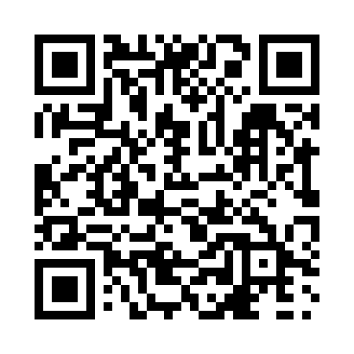
Prayer times for Thornyhurst, Ontario, Canada
Mon 1 Apr 2024 - Tue 30 Apr 2024
High Latitude Method: Angle Based Rule
Prayer Calculation Method: Islamic Society of North America
Asar Calculation Method: Hanafi

Date | Day | Fajr | Sunrise | Dhuhr | Asr | Maghrib | Isha
1 | Mon | 5:51 | 7:11 | 1:33 | 6:03 | 7:56 | 9:16
2 | Tue | 5:49 | 7:09 | 1:33 | 6:04 | 7:58 | 9:18
3 | Wed | 5:47 | 7:08 | 1:33 | 6:05 | 7:59 | 9:19
4 | Thu | 5:46 | 7:06 | 1:33 | 6:06 | 8:00 | 9:20
5 | Fri | 5:44 | 7:04 | 1:32 | 6:06 | 8:01 | 9:22
6 | Sat | 5:42 | 7:02 | 1:32 | 6:07 | 8:02 | 9:23
7 | Sun | 5:40 | 7:01 | 1:32 | 6:08 | 8:03 | 9:25
8 | Mon | 5:38 | 6:59 | 1:31 | 6:09 | 8:04 | 9:26
9 | Tue | 5:36 | 6:57 | 1:31 | 6:09 | 8:06 | 9:27
10 | Wed | 5:34 | 6:56 | 1:31 | 6:10 | 8:07 | 9:29
11 | Thu | 5:32 | 6:54 | 1:31 | 6:11 | 8:08 | 9:30
12 | Fri | 5:30 | 6:52 | 1:30 | 6:12 | 8:09 | 9:32
13 | Sat | 5:28 | 6:51 | 1:30 | 6:12 | 8:10 | 9:33
14 | Sun | 5:26 | 6:49 | 1:30 | 6:13 | 8:11 | 9:34
15 | Mon | 5:24 | 6:47 | 1:30 | 6:14 | 8:12 | 9:36
16 | Tue | 5:22 | 6:46 | 1:29 | 6:14 | 8:14 | 9:37
17 | Wed | 5:20 | 6:44 | 1:29 | 6:15 | 8:15 | 9:39
18 | Thu | 5:18 | 6:43 | 1:29 | 6:16 | 8:16 | 9:40
19 | Fri | 5:17 | 6:41 | 1:29 | 6:17 | 8:17 | 9:42
20 | Sat | 5:15 | 6:39 | 1:28 | 6:17 | 8:18 | 9:43
21 | Sun | 5:13 | 6:38 | 1:28 | 6:18 | 8:19 | 9:45
22 | Mon | 5:11 | 6:36 | 1:28 | 6:19 | 8:20 | 9:46
23 | Tue | 5:09 | 6:35 | 1:28 | 6:19 | 8:22 | 9:48
24 | Wed | 5:07 | 6:33 | 1:28 | 6:20 | 8:23 | 9:49
25 | Thu | 5:05 | 6:32 | 1:28 | 6:21 | 8:24 | 9:51
26 | Fri | 5:03 | 6:30 | 1:27 | 6:21 | 8:25 | 9:52
27 | Sat | 5:02 | 6:29 | 1:27 | 6:22 | 8:26 | 9:54
28 | Sun | 5:00 | 6:28 | 1:27 | 6:23 | 8:27 | 9:55
29 | Mon | 4:58 | 6:26 | 1:27 | 6:23 | 8:28 | 9:57
30 | Tue | 4:56 | 6:25 | 1:27 | 6:24 | 8:30 | 9:59
Prayer times provided by https://www.salahtimes.com

