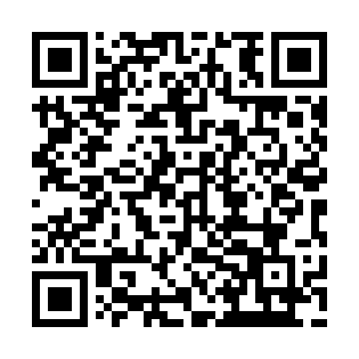
Prayer times for Saint-Maxime-du-Mont-Louis, Quebec, Canada
Mon 1 Jul 2024 - Wed 31 Jul 2024
High Latitude Method: Angle Based Rule
Prayer Calculation Method: Islamic Society of North America
Asar Calculation Method: Hanafi

Date | Day | Fajr | Sunrise | Dhuhr | Asr | Maghrib | Isha
1 | Mon | 2:25 | 4:22 | 12:27 | 5:58 | 8:32 | 10:29
2 | Tue | 2:25 | 4:23 | 12:27 | 5:58 | 8:31 | 10:29
3 | Wed | 2:25 | 4:24 | 12:27 | 5:58 | 8:31 | 10:29
4 | Thu | 2:26 | 4:24 | 12:28 | 5:58 | 8:30 | 10:29
5 | Fri | 2:26 | 4:25 | 12:28 | 5:57 | 8:30 | 10:29
6 | Sat | 2:27 | 4:26 | 12:28 | 5:57 | 8:29 | 10:29
7 | Sun | 2:27 | 4:27 | 12:28 | 5:57 | 8:29 | 10:28
8 | Mon | 2:28 | 4:28 | 12:28 | 5:57 | 8:28 | 10:28
9 | Tue | 2:28 | 4:29 | 12:28 | 5:56 | 8:28 | 10:28
10 | Wed | 2:29 | 4:29 | 12:28 | 5:56 | 8:27 | 10:28
11 | Thu | 2:29 | 4:30 | 12:29 | 5:56 | 8:26 | 10:27
12 | Fri | 2:30 | 4:31 | 12:29 | 5:55 | 8:25 | 10:27
13 | Sat | 2:31 | 4:32 | 12:29 | 5:55 | 8:25 | 10:27
14 | Sun | 2:31 | 4:34 | 12:29 | 5:55 | 8:24 | 10:26
15 | Mon | 2:32 | 4:35 | 12:29 | 5:54 | 8:23 | 10:26
16 | Tue | 2:32 | 4:36 | 12:29 | 5:54 | 8:22 | 10:25
17 | Wed | 2:33 | 4:37 | 12:29 | 5:53 | 8:21 | 10:25
18 | Thu | 2:33 | 4:38 | 12:29 | 5:53 | 8:20 | 10:24
19 | Fri | 2:34 | 4:39 | 12:29 | 5:52 | 8:19 | 10:24
20 | Sat | 2:35 | 4:40 | 12:29 | 5:52 | 8:18 | 10:23
21 | Sun | 2:35 | 4:42 | 12:29 | 5:51 | 8:17 | 10:22
22 | Mon | 2:38 | 4:43 | 12:29 | 5:50 | 8:16 | 10:20
23 | Tue | 2:40 | 4:44 | 12:29 | 5:50 | 8:14 | 10:18
24 | Wed | 2:42 | 4:45 | 12:29 | 5:49 | 8:13 | 10:15
25 | Thu | 2:45 | 4:47 | 12:29 | 5:48 | 8:12 | 10:13
26 | Fri | 2:47 | 4:48 | 12:29 | 5:47 | 8:10 | 10:11
27 | Sat | 2:49 | 4:49 | 12:29 | 5:47 | 8:09 | 10:09
28 | Sun | 2:51 | 4:50 | 12:29 | 5:46 | 8:08 | 10:06
29 | Mon | 2:54 | 4:52 | 12:29 | 5:45 | 8:06 | 10:04
30 | Tue | 2:56 | 4:53 | 12:29 | 5:44 | 8:05 | 10:01
31 | Wed | 2:58 | 4:54 | 12:29 | 5:43 | 8:03 | 9:59
Prayer times provided by https://www.salahtimes.com

