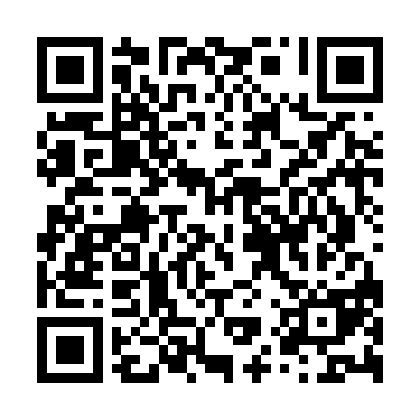
Prayer times for Unter Barkhausen, Germany
Wed 1 May 2024 - Fri 31 May 2024
High Latitude Method: Angle Based Rule
Prayer Calculation Method: Muslim World League
Asar Calculation Method: Shafi

Date | Day | Fajr | Sunrise | Dhuhr | Asr | Maghrib | Isha
1 | Wed | 3:08 | 5:49 | 1:21 | 5:26 | 8:54 | 11:26
2 | Thu | 3:08 | 5:47 | 1:21 | 5:27 | 8:56 | 11:26
3 | Fri | 3:07 | 5:45 | 1:21 | 5:27 | 8:58 | 11:27
4 | Sat | 3:06 | 5:43 | 1:21 | 5:28 | 8:59 | 11:28
5 | Sun | 3:05 | 5:41 | 1:21 | 5:29 | 9:01 | 11:28
6 | Mon | 3:04 | 5:39 | 1:21 | 5:29 | 9:03 | 11:29
7 | Tue | 3:03 | 5:37 | 1:20 | 5:30 | 9:05 | 11:30
8 | Wed | 3:03 | 5:35 | 1:20 | 5:31 | 9:06 | 11:31
9 | Thu | 3:02 | 5:34 | 1:20 | 5:32 | 9:08 | 11:31
10 | Fri | 3:01 | 5:32 | 1:20 | 5:32 | 9:10 | 11:32
11 | Sat | 3:00 | 5:30 | 1:20 | 5:33 | 9:11 | 11:33
12 | Sun | 3:00 | 5:28 | 1:20 | 5:34 | 9:13 | 11:33
13 | Mon | 2:59 | 5:27 | 1:20 | 5:34 | 9:15 | 11:34
14 | Tue | 2:58 | 5:25 | 1:20 | 5:35 | 9:16 | 11:35
15 | Wed | 2:58 | 5:23 | 1:20 | 5:36 | 9:18 | 11:36
16 | Thu | 2:57 | 5:22 | 1:20 | 5:36 | 9:20 | 11:36
17 | Fri | 2:57 | 5:20 | 1:20 | 5:37 | 9:21 | 11:37
18 | Sat | 2:56 | 5:19 | 1:20 | 5:37 | 9:23 | 11:38
19 | Sun | 2:55 | 5:17 | 1:20 | 5:38 | 9:24 | 11:38
20 | Mon | 2:55 | 5:16 | 1:20 | 5:39 | 9:26 | 11:39
21 | Tue | 2:54 | 5:14 | 1:21 | 5:39 | 9:28 | 11:40
22 | Wed | 2:54 | 5:13 | 1:21 | 5:40 | 9:29 | 11:40
23 | Thu | 2:53 | 5:12 | 1:21 | 5:40 | 9:30 | 11:41
24 | Fri | 2:53 | 5:10 | 1:21 | 5:41 | 9:32 | 11:42
25 | Sat | 2:52 | 5:09 | 1:21 | 5:42 | 9:33 | 11:42
26 | Sun | 2:52 | 5:08 | 1:21 | 5:42 | 9:35 | 11:43
27 | Mon | 2:52 | 5:07 | 1:21 | 5:43 | 9:36 | 11:44
28 | Tue | 2:51 | 5:06 | 1:21 | 5:43 | 9:37 | 11:44
29 | Wed | 2:51 | 5:05 | 1:21 | 5:44 | 9:39 | 11:45
30 | Thu | 2:51 | 5:04 | 1:22 | 5:44 | 9:40 | 11:46
31 | Fri | 2:50 | 5:03 | 1:22 | 5:45 | 9:41 | 11:46
Prayer times provided by https://www.salahtimes.com

