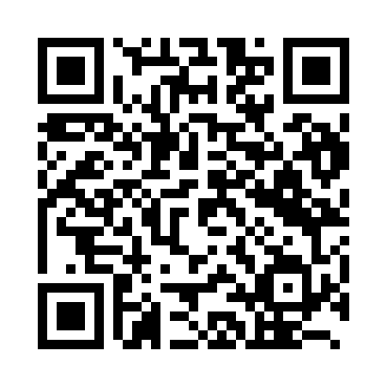
Prayer times for Tokashiki, Japan
Wed 1 May 2024 - Fri 31 May 2024
High Latitude Method: None
Prayer Calculation Method: Muslim World League
Asar Calculation Method: Shafi

Date | Day | Fajr | Sunrise | Dhuhr | Asr | Maghrib | Isha
1 | Wed | 4:30 | 5:53 | 12:28 | 3:58 | 7:02 | 8:20
2 | Thu | 4:29 | 5:52 | 12:28 | 3:58 | 7:03 | 8:21
3 | Fri | 4:28 | 5:52 | 12:27 | 3:58 | 7:03 | 8:22
4 | Sat | 4:27 | 5:51 | 12:27 | 3:57 | 7:04 | 8:23
5 | Sun | 4:27 | 5:50 | 12:27 | 3:57 | 7:05 | 8:23
6 | Mon | 4:26 | 5:50 | 12:27 | 3:57 | 7:05 | 8:24
7 | Tue | 4:25 | 5:49 | 12:27 | 3:57 | 7:06 | 8:25
8 | Wed | 4:24 | 5:48 | 12:27 | 3:57 | 7:06 | 8:25
9 | Thu | 4:23 | 5:48 | 12:27 | 3:56 | 7:07 | 8:26
10 | Fri | 4:22 | 5:47 | 12:27 | 3:56 | 7:07 | 8:27
11 | Sat | 4:21 | 5:46 | 12:27 | 3:56 | 7:08 | 8:28
12 | Sun | 4:21 | 5:46 | 12:27 | 3:56 | 7:08 | 8:28
13 | Mon | 4:20 | 5:45 | 12:27 | 3:56 | 7:09 | 8:29
14 | Tue | 4:19 | 5:45 | 12:27 | 3:56 | 7:09 | 8:30
15 | Wed | 4:18 | 5:44 | 12:27 | 3:56 | 7:10 | 8:31
16 | Thu | 4:17 | 5:44 | 12:27 | 3:56 | 7:11 | 8:31
17 | Fri | 4:17 | 5:43 | 12:27 | 3:55 | 7:11 | 8:32
18 | Sat | 4:16 | 5:43 | 12:27 | 3:55 | 7:12 | 8:33
19 | Sun | 4:15 | 5:42 | 12:27 | 3:55 | 7:12 | 8:34
20 | Mon | 4:15 | 5:42 | 12:27 | 3:55 | 7:13 | 8:34
21 | Tue | 4:14 | 5:41 | 12:27 | 3:55 | 7:13 | 8:35
22 | Wed | 4:14 | 5:41 | 12:27 | 3:55 | 7:14 | 8:36
23 | Thu | 4:13 | 5:41 | 12:27 | 3:55 | 7:14 | 8:37
24 | Fri | 4:12 | 5:40 | 12:27 | 3:55 | 7:15 | 8:37
25 | Sat | 4:12 | 5:40 | 12:28 | 3:55 | 7:15 | 8:38
26 | Sun | 4:11 | 5:40 | 12:28 | 3:55 | 7:16 | 8:39
27 | Mon | 4:11 | 5:39 | 12:28 | 3:55 | 7:16 | 8:39
28 | Tue | 4:11 | 5:39 | 12:28 | 3:55 | 7:17 | 8:40
29 | Wed | 4:10 | 5:39 | 12:28 | 3:55 | 7:17 | 8:41
30 | Thu | 4:10 | 5:39 | 12:28 | 3:55 | 7:18 | 8:41
31 | Fri | 4:09 | 5:38 | 12:28 | 3:55 | 7:18 | 8:42
Prayer times provided by https://www.salahtimes.com

