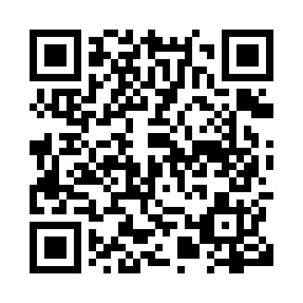
Prayer times for Sakami, Quebec, Canada
Mon 1 Jul 2024 - Wed 31 Jul 2024
High Latitude Method: Angle Based Rule
Prayer Calculation Method: Islamic Society of North America
Asar Calculation Method: Hanafi

Date | Day | Fajr | Sunrise | Dhuhr | Asr | Maghrib | Isha
1 | Mon | 2:54 | 4:39 | 1:08 | 6:50 | 9:37 | 11:23
2 | Tue | 2:54 | 4:40 | 1:08 | 6:49 | 9:37 | 11:23
3 | Wed | 2:55 | 4:41 | 1:09 | 6:49 | 9:36 | 11:22
4 | Thu | 2:55 | 4:42 | 1:09 | 6:49 | 9:36 | 11:22
5 | Fri | 2:56 | 4:43 | 1:09 | 6:49 | 9:35 | 11:22
6 | Sat | 2:56 | 4:44 | 1:09 | 6:49 | 9:34 | 11:22
7 | Sun | 2:57 | 4:45 | 1:09 | 6:48 | 9:34 | 11:21
8 | Mon | 2:57 | 4:46 | 1:09 | 6:48 | 9:33 | 11:21
9 | Tue | 2:58 | 4:47 | 1:10 | 6:48 | 9:32 | 11:21
10 | Wed | 2:59 | 4:48 | 1:10 | 6:47 | 9:31 | 11:20
11 | Thu | 2:59 | 4:49 | 1:10 | 6:47 | 9:30 | 11:20
12 | Fri | 3:00 | 4:50 | 1:10 | 6:46 | 9:29 | 11:19
13 | Sat | 3:01 | 4:52 | 1:10 | 6:46 | 9:28 | 11:19
14 | Sun | 3:01 | 4:53 | 1:10 | 6:45 | 9:27 | 11:19
15 | Mon | 3:02 | 4:54 | 1:10 | 6:45 | 9:26 | 11:18
16 | Tue | 3:03 | 4:55 | 1:10 | 6:44 | 9:25 | 11:17
17 | Wed | 3:04 | 4:57 | 1:11 | 6:43 | 9:24 | 11:17
18 | Thu | 3:04 | 4:58 | 1:11 | 6:43 | 9:22 | 11:16
19 | Fri | 3:05 | 5:00 | 1:11 | 6:42 | 9:21 | 11:16
20 | Sat | 3:06 | 5:01 | 1:11 | 6:41 | 9:20 | 11:15
21 | Sun | 3:07 | 5:03 | 1:11 | 6:41 | 9:18 | 11:14
22 | Mon | 3:07 | 5:04 | 1:11 | 6:40 | 9:17 | 11:14
23 | Tue | 3:08 | 5:06 | 1:11 | 6:39 | 9:15 | 11:13
24 | Wed | 3:09 | 5:07 | 1:11 | 6:38 | 9:14 | 11:12
25 | Thu | 3:10 | 5:09 | 1:11 | 6:37 | 9:12 | 11:11
26 | Fri | 3:10 | 5:10 | 1:11 | 6:36 | 9:10 | 11:10
27 | Sat | 3:11 | 5:12 | 1:11 | 6:35 | 9:09 | 11:10
28 | Sun | 3:12 | 5:14 | 1:11 | 6:34 | 9:07 | 11:09
29 | Mon | 3:13 | 5:15 | 1:11 | 6:33 | 9:05 | 11:08
30 | Tue | 3:14 | 5:17 | 1:11 | 6:32 | 9:04 | 11:07
31 | Wed | 3:14 | 5:18 | 1:11 | 6:31 | 9:02 | 11:06
Prayer times provided by https://www.salahtimes.com

