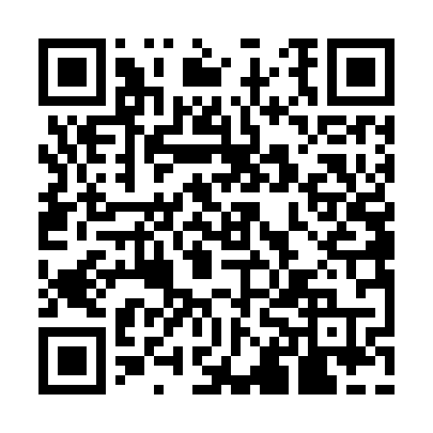
Prayer times for Country Club East, North Carolina, USA
Wed 1 May 2024 - Fri 31 May 2024
High Latitude Method: Angle Based Rule
Prayer Calculation Method: Islamic Society of North America
Asar Calculation Method: Shafi

Date | Day | Fajr | Sunrise | Dhuhr | Asr | Maghrib | Isha
1 | Wed | 5:00 | 6:16 | 1:04 | 4:48 | 7:52 | 9:09
2 | Thu | 4:58 | 6:15 | 1:04 | 4:48 | 7:53 | 9:10
3 | Fri | 4:57 | 6:14 | 1:04 | 4:48 | 7:54 | 9:11
4 | Sat | 4:56 | 6:13 | 1:04 | 4:48 | 7:55 | 9:12
5 | Sun | 4:55 | 6:12 | 1:04 | 4:48 | 7:56 | 9:13
6 | Mon | 4:54 | 6:11 | 1:04 | 4:48 | 7:56 | 9:14
7 | Tue | 4:52 | 6:10 | 1:03 | 4:48 | 7:57 | 9:15
8 | Wed | 4:51 | 6:09 | 1:03 | 4:48 | 7:58 | 9:16
9 | Thu | 4:50 | 6:08 | 1:03 | 4:48 | 7:59 | 9:17
10 | Fri | 4:49 | 6:07 | 1:03 | 4:49 | 8:00 | 9:18
11 | Sat | 4:48 | 6:07 | 1:03 | 4:49 | 8:00 | 9:19
12 | Sun | 4:47 | 6:06 | 1:03 | 4:49 | 8:01 | 9:20
13 | Mon | 4:46 | 6:05 | 1:03 | 4:49 | 8:02 | 9:22
14 | Tue | 4:45 | 6:04 | 1:03 | 4:49 | 8:03 | 9:23
15 | Wed | 4:44 | 6:04 | 1:03 | 4:49 | 8:04 | 9:24
16 | Thu | 4:43 | 6:03 | 1:03 | 4:49 | 8:04 | 9:25
17 | Fri | 4:42 | 6:02 | 1:03 | 4:49 | 8:05 | 9:26
18 | Sat | 4:41 | 6:01 | 1:03 | 4:50 | 8:06 | 9:27
19 | Sun | 4:40 | 6:01 | 1:03 | 4:50 | 8:07 | 9:28
20 | Mon | 4:39 | 6:00 | 1:04 | 4:50 | 8:07 | 9:29
21 | Tue | 4:38 | 6:00 | 1:04 | 4:50 | 8:08 | 9:30
22 | Wed | 4:37 | 5:59 | 1:04 | 4:50 | 8:09 | 9:31
23 | Thu | 4:37 | 5:58 | 1:04 | 4:50 | 8:09 | 9:31
24 | Fri | 4:36 | 5:58 | 1:04 | 4:50 | 8:10 | 9:32
25 | Sat | 4:35 | 5:57 | 1:04 | 4:51 | 8:11 | 9:33
26 | Sun | 4:34 | 5:57 | 1:04 | 4:51 | 8:12 | 9:34
27 | Mon | 4:34 | 5:56 | 1:04 | 4:51 | 8:12 | 9:35
28 | Tue | 4:33 | 5:56 | 1:04 | 4:51 | 8:13 | 9:36
29 | Wed | 4:33 | 5:56 | 1:04 | 4:51 | 8:14 | 9:37
30 | Thu | 4:32 | 5:55 | 1:05 | 4:51 | 8:14 | 9:38
31 | Fri | 4:31 | 5:55 | 1:05 | 4:52 | 8:15 | 9:38
Prayer times provided by https://www.salahtimes.com

