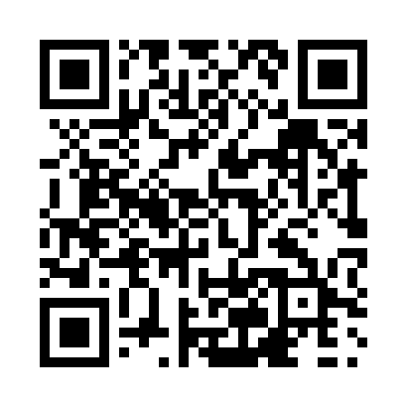
Prayer times for Allison Lake, British Columbia, Canada
Wed 1 May 2024 - Fri 31 May 2024
High Latitude Method: Angle Based Rule
Prayer Calculation Method: Islamic Society of North America
Asar Calculation Method: Hanafi

Date | Day | Fajr | Sunrise | Dhuhr | Asr | Maghrib | Isha
1 | Wed | 3:49 | 5:38 | 12:59 | 6:05 | 8:21 | 10:11
2 | Thu | 3:47 | 5:37 | 12:59 | 6:06 | 8:23 | 10:13
3 | Fri | 3:44 | 5:35 | 12:59 | 6:07 | 8:24 | 10:16
4 | Sat | 3:42 | 5:33 | 12:59 | 6:08 | 8:26 | 10:18
5 | Sun | 3:39 | 5:32 | 12:59 | 6:09 | 8:27 | 10:20
6 | Mon | 3:37 | 5:30 | 12:59 | 6:10 | 8:29 | 10:23
7 | Tue | 3:34 | 5:28 | 12:59 | 6:10 | 8:30 | 10:25
8 | Wed | 3:31 | 5:27 | 12:59 | 6:11 | 8:32 | 10:28
9 | Thu | 3:29 | 5:25 | 12:59 | 6:12 | 8:33 | 10:30
10 | Fri | 3:26 | 5:24 | 12:59 | 6:13 | 8:35 | 10:32
11 | Sat | 3:24 | 5:22 | 12:59 | 6:14 | 8:36 | 10:35
12 | Sun | 3:22 | 5:21 | 12:59 | 6:15 | 8:37 | 10:37
13 | Mon | 3:19 | 5:19 | 12:59 | 6:16 | 8:39 | 10:40
14 | Tue | 3:17 | 5:18 | 12:59 | 6:16 | 8:40 | 10:42
15 | Wed | 3:14 | 5:17 | 12:59 | 6:17 | 8:42 | 10:45
16 | Thu | 3:12 | 5:15 | 12:59 | 6:18 | 8:43 | 10:47
17 | Fri | 3:09 | 5:14 | 12:59 | 6:19 | 8:44 | 10:50
18 | Sat | 3:07 | 5:13 | 12:59 | 6:20 | 8:46 | 10:52
19 | Sun | 3:05 | 5:12 | 12:59 | 6:20 | 8:47 | 10:53
20 | Mon | 3:05 | 5:10 | 12:59 | 6:21 | 8:48 | 10:54
21 | Tue | 3:04 | 5:09 | 12:59 | 6:22 | 8:50 | 10:54
22 | Wed | 3:04 | 5:08 | 12:59 | 6:23 | 8:51 | 10:55
23 | Thu | 3:03 | 5:07 | 12:59 | 6:23 | 8:52 | 10:56
24 | Fri | 3:03 | 5:06 | 12:59 | 6:24 | 8:53 | 10:56
25 | Sat | 3:02 | 5:05 | 12:59 | 6:25 | 8:54 | 10:57
26 | Sun | 3:02 | 5:04 | 1:00 | 6:26 | 8:56 | 10:58
27 | Mon | 3:02 | 5:03 | 1:00 | 6:26 | 8:57 | 10:58
28 | Tue | 3:01 | 5:02 | 1:00 | 6:27 | 8:58 | 10:59
29 | Wed | 3:01 | 5:01 | 1:00 | 6:28 | 8:59 | 11:00
30 | Thu | 3:00 | 5:01 | 1:00 | 6:28 | 9:00 | 11:00
31 | Fri | 3:00 | 5:00 | 1:00 | 6:29 | 9:01 | 11:01
Prayer times provided by https://www.salahtimes.com

