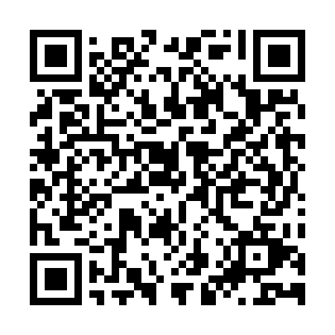
Prayer times for Moncagua, El Salvador
Wed 1 May 2024 - Fri 31 May 2024
High Latitude Method: None
Prayer Calculation Method: Muslim World League
Asar Calculation Method: Shafi

Date | Day | Fajr | Sunrise | Dhuhr | Asr | Maghrib | Isha
1 | Wed | 4:17 | 5:31 | 11:50 | 3:00 | 6:09 | 7:19
2 | Thu | 4:16 | 5:31 | 11:50 | 3:00 | 6:09 | 7:19
3 | Fri | 4:16 | 5:30 | 11:50 | 3:01 | 6:09 | 7:20
4 | Sat | 4:15 | 5:30 | 11:50 | 3:02 | 6:09 | 7:20
5 | Sun | 4:15 | 5:30 | 11:50 | 3:02 | 6:10 | 7:20
6 | Mon | 4:14 | 5:29 | 11:50 | 3:03 | 6:10 | 7:21
7 | Tue | 4:14 | 5:29 | 11:49 | 3:03 | 6:10 | 7:21
8 | Wed | 4:13 | 5:29 | 11:49 | 3:04 | 6:10 | 7:21
9 | Thu | 4:13 | 5:28 | 11:49 | 3:04 | 6:11 | 7:22
10 | Fri | 4:12 | 5:28 | 11:49 | 3:05 | 6:11 | 7:22
11 | Sat | 4:12 | 5:28 | 11:49 | 3:05 | 6:11 | 7:23
12 | Sun | 4:11 | 5:27 | 11:49 | 3:06 | 6:11 | 7:23
13 | Mon | 4:11 | 5:27 | 11:49 | 3:06 | 6:12 | 7:23
14 | Tue | 4:11 | 5:27 | 11:49 | 3:07 | 6:12 | 7:24
15 | Wed | 4:10 | 5:27 | 11:49 | 3:07 | 6:12 | 7:24
16 | Thu | 4:10 | 5:26 | 11:49 | 3:08 | 6:12 | 7:25
17 | Fri | 4:09 | 5:26 | 11:49 | 3:08 | 6:13 | 7:25
18 | Sat | 4:09 | 5:26 | 11:49 | 3:09 | 6:13 | 7:25
19 | Sun | 4:09 | 5:26 | 11:49 | 3:09 | 6:13 | 7:26
20 | Mon | 4:08 | 5:26 | 11:50 | 3:10 | 6:14 | 7:26
21 | Tue | 4:08 | 5:25 | 11:50 | 3:10 | 6:14 | 7:27
22 | Wed | 4:08 | 5:25 | 11:50 | 3:11 | 6:14 | 7:27
23 | Thu | 4:08 | 5:25 | 11:50 | 3:11 | 6:14 | 7:27
24 | Fri | 4:07 | 5:25 | 11:50 | 3:11 | 6:15 | 7:28
25 | Sat | 4:07 | 5:25 | 11:50 | 3:12 | 6:15 | 7:28
26 | Sun | 4:07 | 5:25 | 11:50 | 3:12 | 6:15 | 7:29
27 | Mon | 4:07 | 5:25 | 11:50 | 3:13 | 6:16 | 7:29
28 | Tue | 4:07 | 5:25 | 11:50 | 3:13 | 6:16 | 7:29
29 | Wed | 4:06 | 5:25 | 11:50 | 3:14 | 6:16 | 7:30
30 | Thu | 4:06 | 5:25 | 11:51 | 3:14 | 6:17 | 7:30
31 | Fri | 4:06 | 5:25 | 11:51 | 3:14 | 6:17 | 7:31
Prayer times provided by https://www.salahtimes.com

