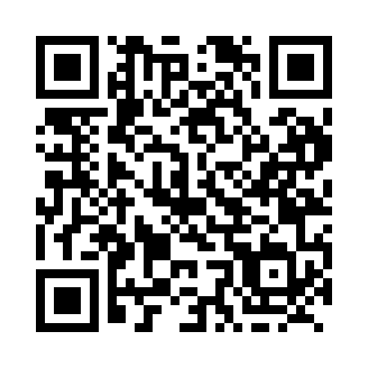
Prayer times for Glen Park, Alberta, Canada
Mon 1 Apr 2024 - Tue 30 Apr 2024
High Latitude Method: Angle Based Rule
Prayer Calculation Method: Islamic Society of North America
Asar Calculation Method: Hanafi

Date | Day | Fajr | Sunrise | Dhuhr | Asr | Maghrib | Isha
1 | Mon | 5:27 | 7:08 | 1:39 | 6:06 | 8:12 | 9:53
2 | Tue | 5:24 | 7:05 | 1:39 | 6:08 | 8:14 | 9:56
3 | Wed | 5:21 | 7:03 | 1:39 | 6:09 | 8:16 | 9:58
4 | Thu | 5:18 | 7:00 | 1:38 | 6:10 | 8:17 | 10:00
5 | Fri | 5:15 | 6:58 | 1:38 | 6:11 | 8:19 | 10:02
6 | Sat | 5:12 | 6:56 | 1:38 | 6:13 | 8:21 | 10:05
7 | Sun | 5:09 | 6:53 | 1:38 | 6:14 | 8:23 | 10:07
8 | Mon | 5:07 | 6:51 | 1:37 | 6:15 | 8:25 | 10:10
9 | Tue | 5:04 | 6:49 | 1:37 | 6:17 | 8:26 | 10:12
10 | Wed | 5:01 | 6:46 | 1:37 | 6:18 | 8:28 | 10:14
11 | Thu | 4:58 | 6:44 | 1:37 | 6:19 | 8:30 | 10:17
12 | Fri | 4:55 | 6:42 | 1:36 | 6:20 | 8:32 | 10:19
13 | Sat | 4:52 | 6:39 | 1:36 | 6:21 | 8:34 | 10:22
14 | Sun | 4:49 | 6:37 | 1:36 | 6:23 | 8:35 | 10:24
15 | Mon | 4:46 | 6:35 | 1:36 | 6:24 | 8:37 | 10:27
16 | Tue | 4:43 | 6:33 | 1:35 | 6:25 | 8:39 | 10:30
17 | Wed | 4:39 | 6:30 | 1:35 | 6:26 | 8:41 | 10:32
18 | Thu | 4:36 | 6:28 | 1:35 | 6:27 | 8:43 | 10:35
19 | Fri | 4:33 | 6:26 | 1:35 | 6:29 | 8:44 | 10:38
20 | Sat | 4:30 | 6:24 | 1:34 | 6:30 | 8:46 | 10:40
21 | Sun | 4:27 | 6:21 | 1:34 | 6:31 | 8:48 | 10:43
22 | Mon | 4:24 | 6:19 | 1:34 | 6:32 | 8:50 | 10:46
23 | Tue | 4:21 | 6:17 | 1:34 | 6:33 | 8:52 | 10:49
24 | Wed | 4:18 | 6:15 | 1:34 | 6:34 | 8:53 | 10:51
25 | Thu | 4:14 | 6:13 | 1:34 | 6:36 | 8:55 | 10:54
26 | Fri | 4:11 | 6:11 | 1:33 | 6:37 | 8:57 | 10:57
27 | Sat | 4:08 | 6:09 | 1:33 | 6:38 | 8:59 | 11:00
28 | Sun | 4:05 | 6:07 | 1:33 | 6:39 | 9:01 | 11:03
29 | Mon | 4:01 | 6:05 | 1:33 | 6:40 | 9:02 | 11:06
30 | Tue | 3:58 | 6:03 | 1:33 | 6:41 | 9:04 | 11:09
Prayer times provided by https://www.salahtimes.com

