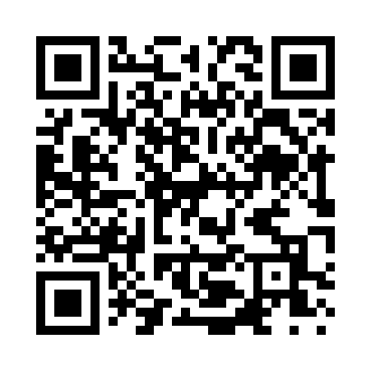
Prayer times for Saint Malo, Louisiana, USA
Mon 1 Jul 2024 - Wed 31 Jul 2024
High Latitude Method: Angle Based Rule
Prayer Calculation Method: Islamic Society of North America
Asar Calculation Method: Shafi

Date | Day | Fajr | Sunrise | Dhuhr | Asr | Maghrib | Isha
1 | Mon | 4:44 | 6:01 | 1:02 | 4:38 | 8:03 | 9:21
2 | Tue | 4:44 | 6:02 | 1:03 | 4:38 | 8:03 | 9:21
3 | Wed | 4:45 | 6:02 | 1:03 | 4:38 | 8:03 | 9:21
4 | Thu | 4:45 | 6:03 | 1:03 | 4:38 | 8:03 | 9:21
5 | Fri | 4:46 | 6:03 | 1:03 | 4:39 | 8:03 | 9:20
6 | Sat | 4:46 | 6:04 | 1:03 | 4:39 | 8:03 | 9:20
7 | Sun | 4:47 | 6:04 | 1:03 | 4:39 | 8:03 | 9:20
8 | Mon | 4:48 | 6:05 | 1:04 | 4:39 | 8:03 | 9:19
9 | Tue | 4:48 | 6:05 | 1:04 | 4:39 | 8:02 | 9:19
10 | Wed | 4:49 | 6:06 | 1:04 | 4:40 | 8:02 | 9:19
11 | Thu | 4:49 | 6:06 | 1:04 | 4:40 | 8:02 | 9:18
12 | Fri | 4:50 | 6:07 | 1:04 | 4:40 | 8:02 | 9:18
13 | Sat | 4:51 | 6:07 | 1:04 | 4:40 | 8:01 | 9:17
14 | Sun | 4:51 | 6:08 | 1:04 | 4:40 | 8:01 | 9:17
15 | Mon | 4:52 | 6:08 | 1:04 | 4:40 | 8:01 | 9:16
16 | Tue | 4:53 | 6:09 | 1:05 | 4:41 | 8:00 | 9:16
17 | Wed | 4:54 | 6:09 | 1:05 | 4:41 | 8:00 | 9:15
18 | Thu | 4:54 | 6:10 | 1:05 | 4:41 | 7:59 | 9:15
19 | Fri | 4:55 | 6:10 | 1:05 | 4:41 | 7:59 | 9:14
20 | Sat | 4:56 | 6:11 | 1:05 | 4:41 | 7:58 | 9:13
21 | Sun | 4:57 | 6:12 | 1:05 | 4:41 | 7:58 | 9:13
22 | Mon | 4:57 | 6:12 | 1:05 | 4:41 | 7:57 | 9:12
23 | Tue | 4:58 | 6:13 | 1:05 | 4:41 | 7:57 | 9:11
24 | Wed | 4:59 | 6:13 | 1:05 | 4:41 | 7:56 | 9:11
25 | Thu | 5:00 | 6:14 | 1:05 | 4:41 | 7:56 | 9:10
26 | Fri | 5:00 | 6:14 | 1:05 | 4:41 | 7:55 | 9:09
27 | Sat | 5:01 | 6:15 | 1:05 | 4:41 | 7:54 | 9:08
28 | Sun | 5:02 | 6:16 | 1:05 | 4:41 | 7:54 | 9:07
29 | Mon | 5:03 | 6:16 | 1:05 | 4:41 | 7:53 | 9:06
30 | Tue | 5:04 | 6:17 | 1:05 | 4:41 | 7:52 | 9:06
31 | Wed | 5:04 | 6:17 | 1:05 | 4:41 | 7:52 | 9:05
Prayer times provided by https://www.salahtimes.com

