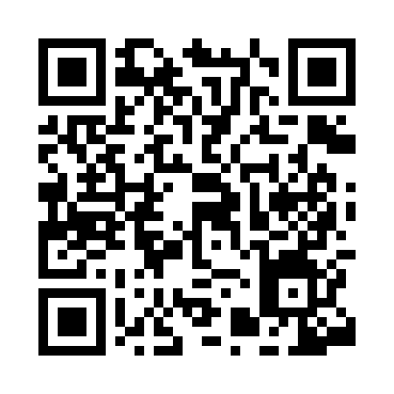
Prayer times for Al Maso, Italy
Wed 1 May 2024 - Fri 31 May 2024
High Latitude Method: Angle Based Rule
Prayer Calculation Method: Muslim World League
Asar Calculation Method: Hanafi

Date | Day | Fajr | Sunrise | Dhuhr | Asr | Maghrib | Isha
1 | Wed | 3:58 | 6:01 | 1:13 | 6:15 | 8:26 | 10:21
2 | Thu | 3:56 | 6:00 | 1:13 | 6:16 | 8:27 | 10:23
3 | Fri | 3:53 | 5:58 | 1:13 | 6:17 | 8:29 | 10:25
4 | Sat | 3:51 | 5:57 | 1:13 | 6:17 | 8:30 | 10:27
5 | Sun | 3:49 | 5:55 | 1:13 | 6:18 | 8:31 | 10:29
6 | Mon | 3:46 | 5:54 | 1:13 | 6:19 | 8:32 | 10:32
7 | Tue | 3:44 | 5:52 | 1:13 | 6:20 | 8:34 | 10:34
8 | Wed | 3:41 | 5:51 | 1:13 | 6:21 | 8:35 | 10:36
9 | Thu | 3:39 | 5:50 | 1:13 | 6:21 | 8:36 | 10:38
10 | Fri | 3:37 | 5:48 | 1:13 | 6:22 | 8:38 | 10:40
11 | Sat | 3:34 | 5:47 | 1:13 | 6:23 | 8:39 | 10:42
12 | Sun | 3:32 | 5:46 | 1:13 | 6:24 | 8:40 | 10:44
13 | Mon | 3:30 | 5:44 | 1:13 | 6:24 | 8:41 | 10:47
14 | Tue | 3:27 | 5:43 | 1:13 | 6:25 | 8:43 | 10:49
15 | Wed | 3:25 | 5:42 | 1:13 | 6:26 | 8:44 | 10:51
16 | Thu | 3:23 | 5:41 | 1:13 | 6:26 | 8:45 | 10:53
17 | Fri | 3:21 | 5:40 | 1:13 | 6:27 | 8:46 | 10:55
18 | Sat | 3:18 | 5:39 | 1:13 | 6:28 | 8:47 | 10:57
19 | Sun | 3:16 | 5:37 | 1:13 | 6:29 | 8:48 | 10:59
20 | Mon | 3:14 | 5:36 | 1:13 | 6:29 | 8:50 | 11:01
21 | Tue | 3:12 | 5:35 | 1:13 | 6:30 | 8:51 | 11:04
22 | Wed | 3:10 | 5:34 | 1:13 | 6:31 | 8:52 | 11:06
23 | Thu | 3:08 | 5:34 | 1:13 | 6:31 | 8:53 | 11:08
24 | Fri | 3:05 | 5:33 | 1:13 | 6:32 | 8:54 | 11:10
25 | Sat | 3:03 | 5:32 | 1:13 | 6:32 | 8:55 | 11:12
26 | Sun | 3:01 | 5:31 | 1:13 | 6:33 | 8:56 | 11:14
27 | Mon | 2:59 | 5:30 | 1:13 | 6:34 | 8:57 | 11:16
28 | Tue | 2:58 | 5:29 | 1:14 | 6:34 | 8:58 | 11:18
29 | Wed | 2:56 | 5:29 | 1:14 | 6:35 | 8:59 | 11:20
30 | Thu | 2:56 | 5:28 | 1:14 | 6:35 | 9:00 | 11:21
31 | Fri | 2:55 | 5:27 | 1:14 | 6:36 | 9:01 | 11:23
Prayer times provided by https://www.salahtimes.com

